Susquehanna Shale Hills  Field Safety protocols | This is a living document for maintaining field safety. The document will be updated at least annually.  Brandon Forsythe

Table of Contents
Field Safety 3
Emergency Contacts 3
Emergency Contacts 3
Accident Reporting 4
General Guidelines 4
Logistics 4
Weather 5
Lightning 5
Heat/Sun Exposure 5
Animals 7
Ticks 8
Snakes 8
Bees & Hornets 9
Plants 10
Water Safety 10
Tower Safety 11
Vehicle 11

Field Safety

Emergency Contacts

- General guidelines

- Logistics

- Weather

- Animals

- Plants

- Water

Emergency Contacts

Ambulance, Fire, Police: 911

Penn State University Police: (814) 863-1111

Penn State University Health and Safety

(814) 865-6391

http://www.ehs.psu.edu/

Mount Nittany Medical Center (814) 231-7000

1800 East Park Ave

State College, PA

JC Blair Hospital (814) 643-2290

1225 Warm Springs Ave

Huntingdon, PA 16652

Accident Reporting

Reporting of an accident follows Penn State University Safety Policies:

SY01 Environmental Health and Safety Policy

SY03 Emergencies Involving Students

SY04 Employee Accidents Reporting and Investigation

SY05 Injuries to any Person, and Reporting Incidents Involving Other than Employees

General Guidelines

YOU ARE IN CHARGE OF YOUR OWN PERSONAL SAFETY

- If you are uncomfortable or do not feel safe make Brandon Forsythe or other field staff/personnel/colleagues aware of the condition(s) so it can be fixed or an alternative can be found.

- Use common sense!

- Do not wonder off by yourself; let someone know where you are:
  - Departure time
  - Expected return time:
  - Contact information:
    - Cell phone numbers
    - Vehicle descriptions

- Ideally at least one person should have a cell phone in case of emergencies

- Not all places have cellular reception

- Wear appropriate field clothing

- Closed toed shoes such as hiking boots or sneakers
- Long pants and long sleeve shirts are recommended to protect against ticks and other hazards
- Sunblock, sun glasses, hat
- Rain gear

Logistics

- Plan ahead

- Email field plans to Watershed Specialist
  - Watershed Specialist will help schedule other colleagues to help in field
  - Schedule will be posted to the Field Calendar
  - If schedule changes notify Watershed Specialist to change calendar

- Have a field buddy – a 2nd person can help get work done and can obtain help in case of emergency; especially where no cell signal is available

Weather

Weather conditions can change rapidly and vary between campus and field work locations. Have appropriate clothing, food, and water while in field.

Lightning

- Seek shelter early – building or vehicle
  - Stay sheltered for 30 minutes after last lightning or thunder strike
  - If no shelter stay low to the ground – DO NOT be the tallest thing around

- Lightning kills an average of 47 people per year (http://www.lightningsafety.noaa.gov/)

- OSHA guidelines for lightning when working outdoors https://www.osha.gov/Publications/OSHA3863.pdf

Heat/Sun Exposure

- Cover your skin – tightly woven fabrics
- Use sunscreen – SPF 15 or greater; follow directions on the bottle
- Wear a hat – wide brim hats are idea to protect the ears, nose, necks, eyes
- Sunglasses – should block 99 to 100% of UVA and UBA radiation
- Try to limit direct exposure time – UV rays are strongest between 10am and 4pm

Heat Stroke, Heat Exhaustion, Heat Cramps
These definitions come directly from the American Red Cross (redcross.org)
Further guidance and information can also be obtained from OSHA at the following links:
https://www.osha.gov/SLTC/heatstress/heat_illnesses.html

Heat Stroke - a life-threatening condition that usually occurs by ignoring the signals of heat exhaustion. Heat stroke develops when the body systems are overwhelmed by heat and begin to stop functioning. Heat stroke is a medical emergency that can result in death. Call 911 immediately!!!

Heat Exhaustion - a more severe condition than heat cramps. Heat exhaustion often affects athletes, firefighters, construction workers and factory workers. It also affects those wearing heavy clothing in a hot, humid environment. Signs of heat exhaustion include cool, moist, pale, ashen or flushed skin; headache; nausea; dizziness; weakness; and exhaustion.

Heat Cramps - are muscular pains and spasms that usually occur in the legs or abdomen. Heat cramps are often an early sign that the body is having trouble with the heat.

- Prevention - https://www.osha.gov/SLTC/heatstress/prevention.html\
  - Stay hydrated – small amounts more frequently
  - Wear light colored clothing
  - Take breaks in shade
  - Avoid caffeine, alcohol, and sugars
  - Work in shaded areas when possible
  - Ask your doctor if you have concerns about your health and medications

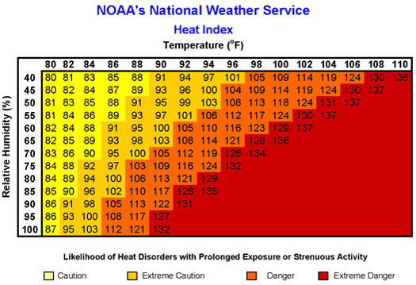

Heat Index | Risk Level | Protective Measures
Less than 91°F | Lower (Caution) | Basic heat safety and planning
91°F to 103°F | Moderate | Implement precautions and heighten awareness
103°F to 115°F | High | Additional precautions to protect workers
Greater than 115°F | Very High to Extreme | Triggers even more aggressive protective measures

Animals

Ticks – 25 known species identified in Pennsylvania; 4 Major Ticks in this region are:

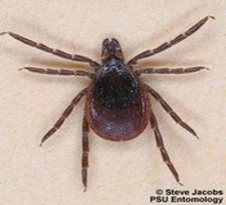
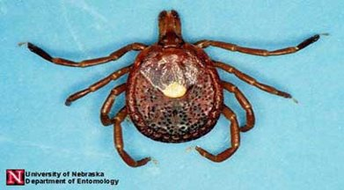
Black Legged or Deer Tick
Lonestar Tick

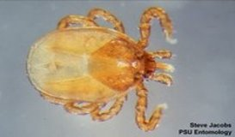
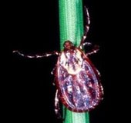
Groundhog Tick
Dog Tick

- Frequently check yourself for ticks. Ticks like the warm moist areas.
- Prevention and control:
  - Wear light colored clothing, long sleeve shirt and long pants
  - Tuck pants into socks, boots, or gaitors
  - Use Tick repellents
    - Permethrin products
      - Use on clothing only
      - Follow product instructions carefully
    - DEET
      - 30-40% DEET
      - Can use on skin and clothing

Snakes

Three venomous snakes in PA

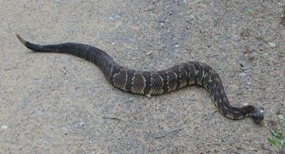
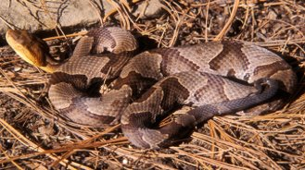
Timber Rattlesnake
Northern Copperhead

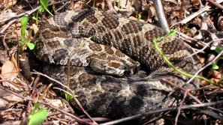

Eastern Massasauga Rattlesnake (rare - Northwestern PA)

- Do not get close to snakes – typically they will not bother you if you let them alone. KEEP YOUR DISTANCE!
- Rattle snakes typically give a warning by rattling their tails and visually coil up
- Copperheads will coil up sometimes but not always
- Snakes blend into their surrounding very well
  - Pay attention to your surroundings and Look before you step or reach down

Bees & Hornets

- Bees and hornets (wasps) can have nests just about anywhere. Be on the lookout in some of these common places
  - Stumps
  - Logs
  - Hanging nests
  - Around any data logger boxes or other structures
- If allergic, be sure to have your medicine with you
  - Let others know so they can help you
  - Show them how to administer an Epi-Pen if you have one

Plants

- The three main poisonous plants are:
  - Poison Oak
  - Poison Sumac
  - Poison Ivy
- More information can be found at The Virtual Nature Trail at Penn State New Kensington (psu.edu)
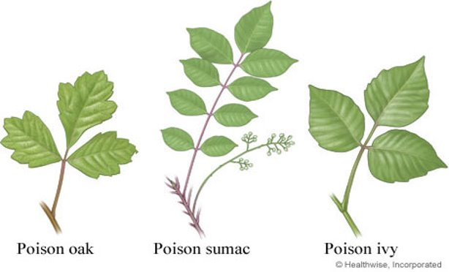

Water Safety

- Work in or around water that you are comfortable with
  - If you cannot swim do not try to wade rivers
- OSHA regulation 29 CFR 1926.106
  - “Employees working over or near water, where the danger of drowning exists, shall be provided U.S. Coast Guard approved life jacket or buoyant work vests.”
  - This includes walking over bridges to collect samples from the bridge
- Powered Boating Crafts
  - PA requires all operators, regardless of age, to complete boater education
  - Boat (fishandboat.com)

Tower Safety

- Individuals must complete a commercial tower training certification prior to climbing any tower
- In addition, you must complete the Fall Protection Safety Training available through PSU EHS: EHS Course Registration: Course List (psu.edu)
- During time climbing be sure to check weather conditions
  - Winds cannot exceed 15 mph
  - Do Not climb in rain or snow
  - Be sure to check tower for ice during winter months
- Must have minimum of 2 certified people on site during the entire climb
  - Prefer an additional third person when feasible
- All participants must wear helmet
- Two certified climbers must have harness on at all times

Vehicle

- University Policy BS20 requires employees between ages 18 and 21 to complete the Online Driver Safety Training Course (PSU Web Access Required).
  - Our group requires ALL users that drive a University vehicle (CZO field vehicle) complete the above course.

