Vegetation Survey Methods and Assumptions

The vegetation survey to validate LiDAR data was conducted during Summer 2010 in the Stone Valley Recreation Area. The survey focused on the Leading Ridge forest area, a meadow site next to a creek, and a wetlands area.

The survey protocol closely follows Vegetation ground truth guidelines for validating lidar products by Qinghua Guo. Thirty-nine plots of 15 m radius each were surveyed. The survey team collected the following data:

- Geographic coordinate of the plot center. Note that these coordinates are approximate at this time and will need to be re-measured during “leaf-off” for greater precision. Plot centers were typically a tree that was flagged for easy visibility for return visits.
- Species name. In the forest areas, the genus and species of each of the trees equal to or more than 18cm DBH were recorded. In the meadow and wetland sites, the species of any trees over 18cm were recorded along with the predominant woody shrubs and herbaceous plants in each of the plots. An effort was made to identify plants down to the genus and species when possible. Voucher specimens were collected from the meadow and wetland sites and will be saved for about the next year for reference. The survey team consulted a plant taxonomist for questions during identification.
- Tree height. The “height routine” on a laser rangefinder (TruPulse 360 B, Laser Technology Inc.) was used for this data collection. The final tree height is the average of 3 data points collected. As it was challenging to take tree height measurements in the middle of a dense forest, we took some practice measurements at first to make sure we were getting reasonable results, before recording the three measurements for each tree.
- Vegetation height. We measured tree height in Leading Ridge, and tree height and vegetation height in the meadow and wetland sites. Vegetation heights were measured with a measuring tape at each point that canopy closure was collected, in each of four directions – the height of the plant closest to each of these directions was recorded, and the four measurements were averaged.
- Number of trees in each plot.
- Diameter at breast height (DBH). The DBH of all trees over 18 cm (and corresponding species and height) were recorded ("Pro Tape" Diameter tape, Spencer Products Company). As we were using DBH tape in standard, rather than metric measurements, we included any trees 7 inches DBH or greater in the survey (18cm = 7.08in). DBH was measured at approximately 1.3m off the ground. Each individual measuring DBH determined where 1.3m lined up on his or her torso. When trees were located on a slope, 1.3m was approximated on the upslope side of the tree.
- Crown Class. The following categories from the original protocol were used:
D Dominant: Trees with crowns extending above the general level of the crown cover and receiving full light from above and partly from the side.
CD Co-dominant: Trees with crowns forming the general level of the crown cover and receiving full light from above, but comparatively little from the sides.
I Intermediate: Trees shorter than those in the two classes above but with crowns either below or extending into the above crown cover receiving little direct light from above and none from the sides.
S Suppressed: Trees with crowns entirely below the general level of the crown cover, receiving no direct light either from above or from the sides.
- Crown Closure. A Forest Densiometers Spherical Densiometer Concave - Model C was used. The following protocol was used for the crown closure data collection:

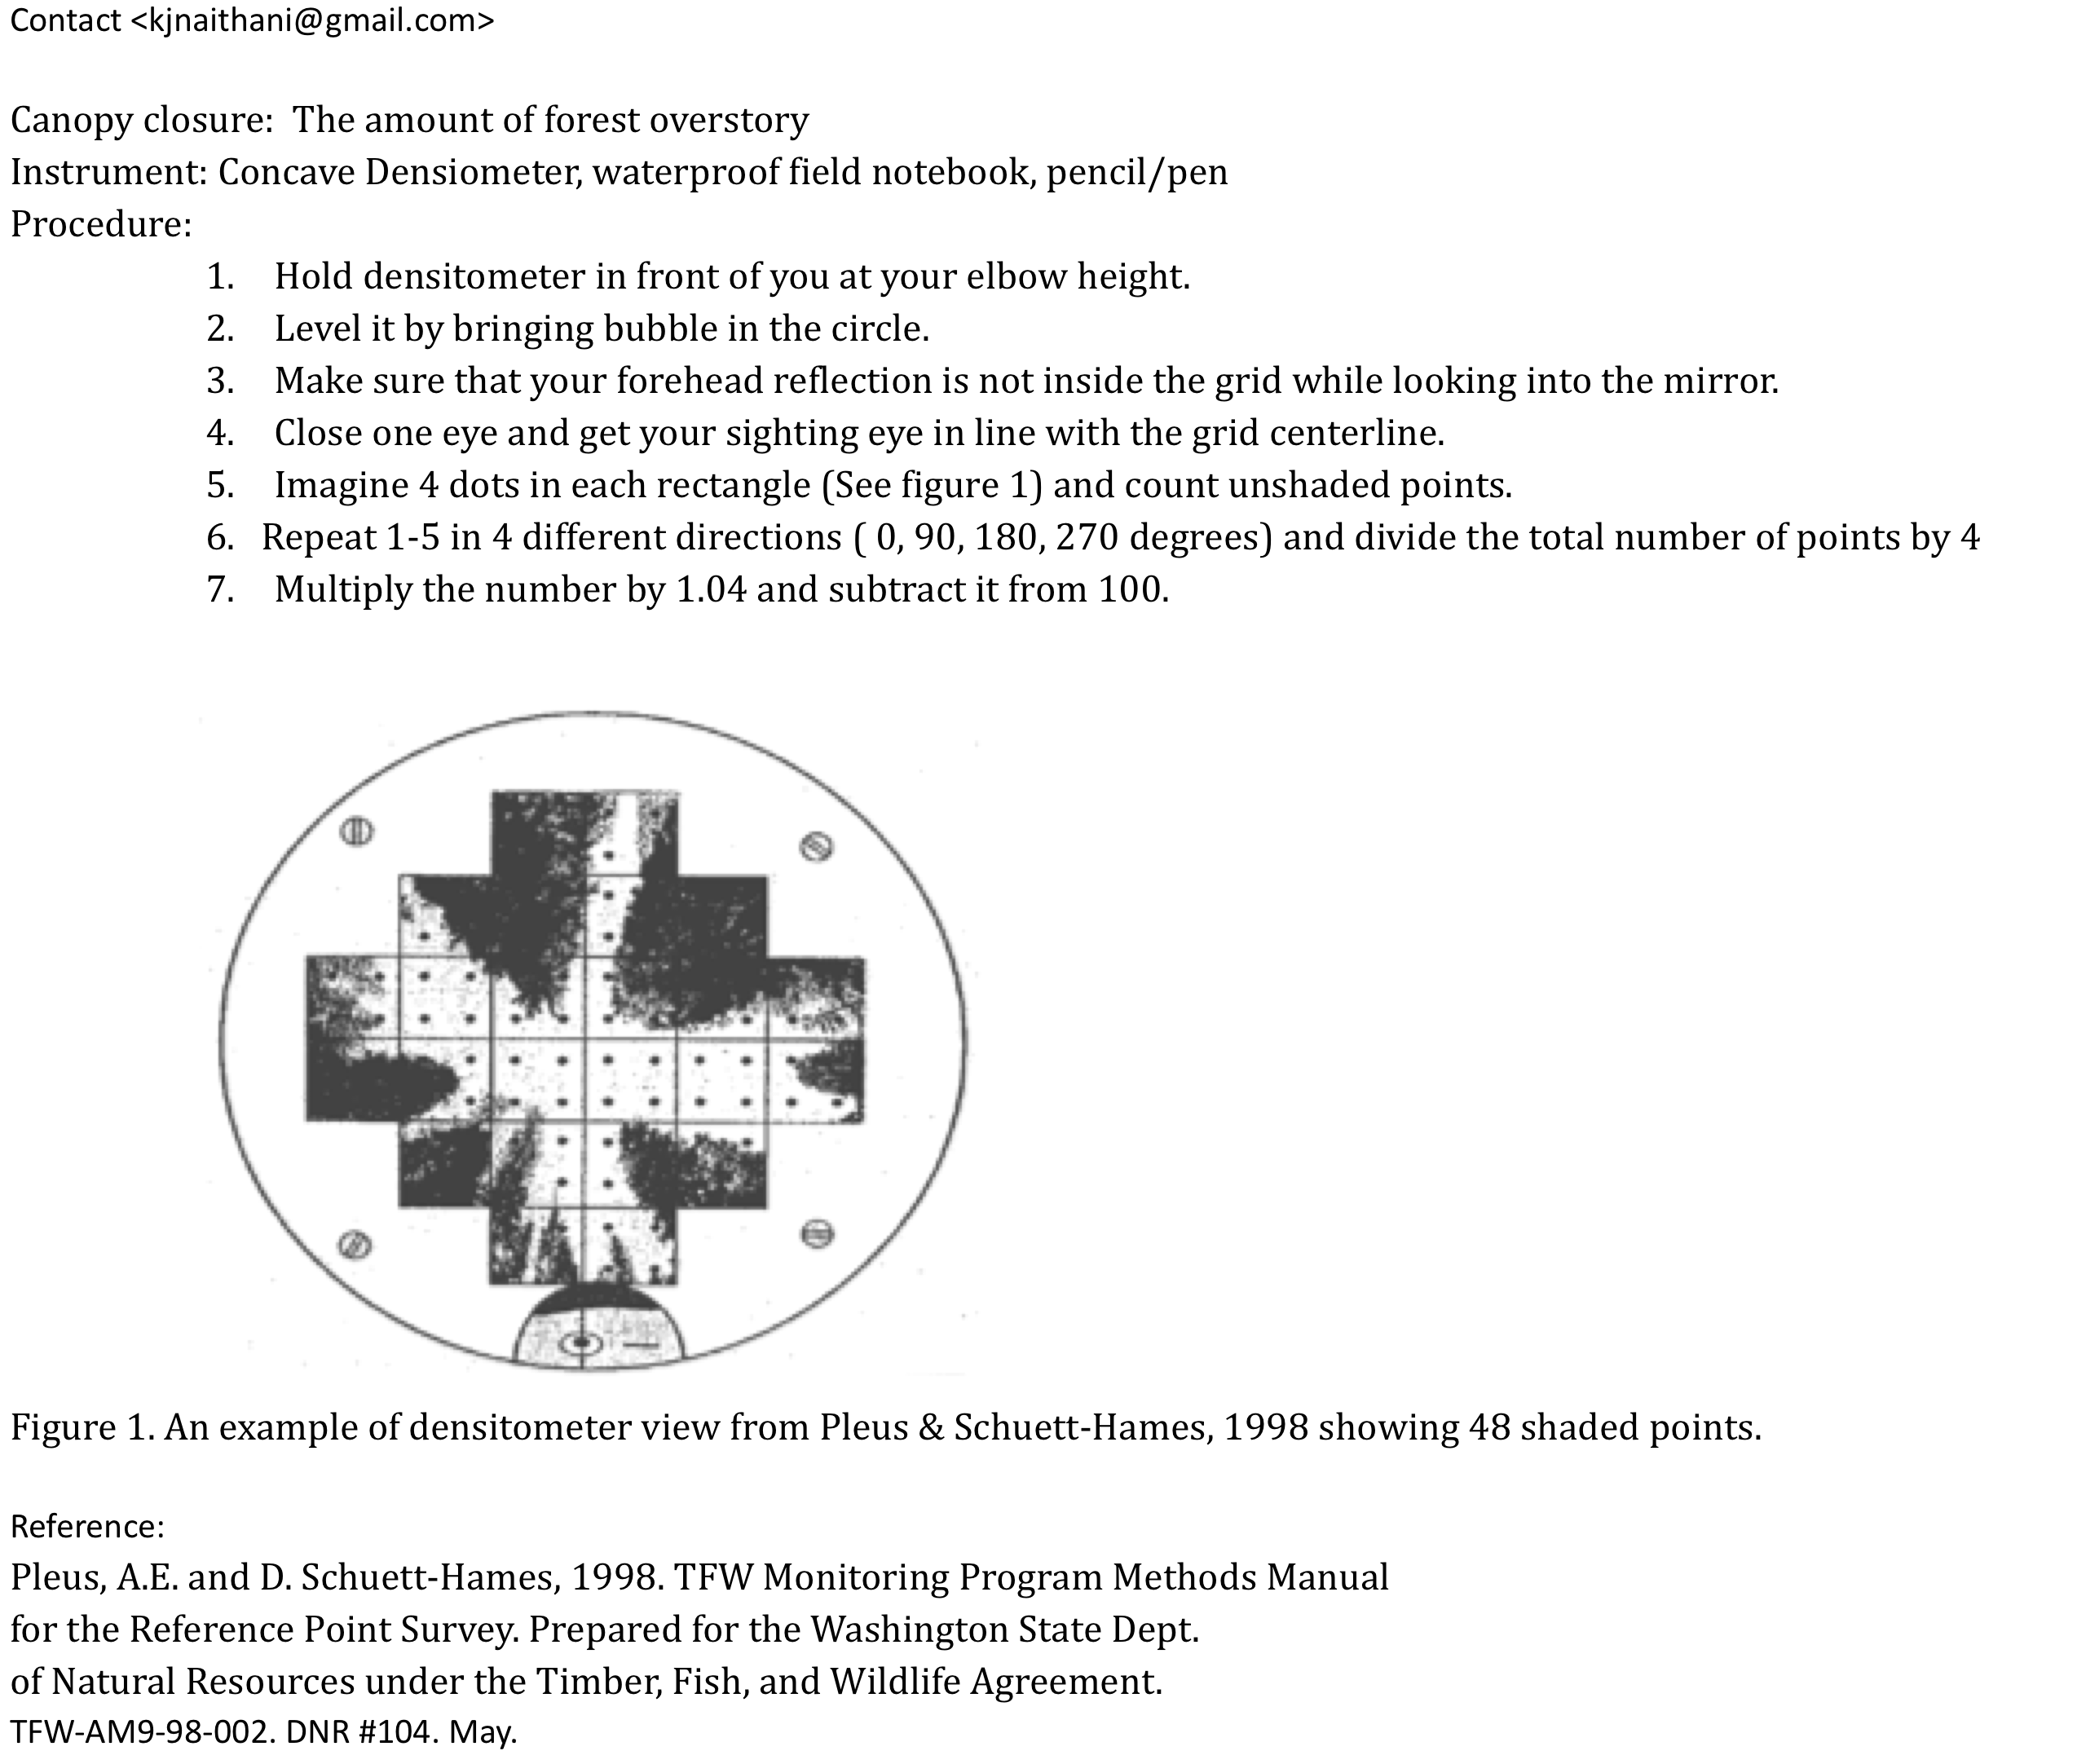
Crown closure was collected in each of the four cardinal directions at 5 points in each 15m radius plot: at the plot center, 7m North of plot center, 7m East of plot center, 7 m South of plot center, and 7m West of plot center. The 7m distance was originally measured out with surveying tape, then one individual paced out this distance 2 or 3 times, determined the average number of paces needed to travel 7m, and counted out paces to determine 7m distance for the remainder of the data collection.

- Leaf area index (LAI). A LI-COR 2200 Leaf Area Meter was used with the 45 degree angle lens cap for all of the plots. Each leaf area index measurement is an average of measurements taken in the 4 cardinal directions, the value for each plot is an average of 6 different sites in each plot. The 6 different sites were measured at the following locations – the individual measuring LAI also paced out these locations in each of the plots:
  - (1) 5m East of plot center
  - (2) 5 m West of plot center
  - (3) 12.5m NE of plot center
  - (4) 12.5m SE of plot center
  - (5) 12.5m SW of plot center
  - (6) 12.5m NW of plot center
- Plot photographs of the Leading Ridge and meadow and wetland sites were taken from the edge of each plot from each of the cardinal directions (N,S,E,W) facing towards the plot center.

Similar data was collected at Shale Hills in order to be able to validate the LiDAR data for that particular research site. In 2008, a full survey of all trees over 18cm DBH was conducted: tree species, GPS coordinates, and DBH were measured. This summer, we collected a sampling of data on tree height throughout the watershed and limited DBH measurements. We plan to check our DBH results against the results collected in 2008 to see if there are significant differences. We plan to continue measuring DBH this fall in Shale Hills if significant differences were seen versus the 2008 data.

LAI and canopy closure measurements at Shale Hills have been conducted regularly since March of this year (2010). From March until April, the lab was using a Decagon Accupar meter. In May 2010, the lab purchased a LI-COR 2200 leaf area meter. The canopy closure measurements at Shale Hills are taken with a convex densiometer (a concave densiometer was used for the survey plots for consistency with the other CZO locations). Between 60 and 95 sampling points are collected at each sampling date. Samples are collected biweekly on average.

Survey Timeline - 2010

- Mapping out transects, finding approximate GPS points in the field, and flagging trees or plot center – May and June
- Plant identification in meadow and wetland sites – Week of May 24
- Tree height, DBH, crown closure and species identification at Leading Ridge – End of June and early July
- LAI, canopy closure, and plot/species photographs at Leading Ridge – July 14-15
- LAI, canopy closure, and plot/individual species photographs at meadow and wetland – July 19, and July 23 (LAI data will be used from the 7/23 sampling date since the 6th LAI location in meadow plot 2 was inadvertently skipped on the 19th)
- LAI and canopy closure at Shale Hills – July 19

