SSHCZO Metadata Worksheet

Data File Name | SPMS_automated_gas_sample_Level_0.csv
Date Prepared | 2018-01-09
Descriptive Title | Automated Soil Gas Samples
Update Frequency | Hourly
Abstract | Hourly automated sampling of O₂ and CO₂ in soils of the south planar midslope of Shale Hills This automated gas collection is ongoing as part of the larger GroundHOG dataset that includes soil gas, soil moisture, and pore water chemistry. These automated soil gas measurements are taken from a surface and subsurface horizon at each of the sites. These data provide key information on predominate weathering processes, microbial respiration, and tree root activity.
Investigator  Contact Info | Jason Kaye, Professor of Soil Biogeochemistry, Penn State, jpk12@psu.edu  Caitlin Hodges, PhD student in Soil Science and Biogeochemistry, Penn State, cah423@psu.edu  Ben Dillner, Master’s student in Ecology, Penn State, bmd42@psu.edu
Data Value Descriptions | Gas Sample datasets:  - COL1: label = TmStamp, TimeZone = UTC  - COL2: label = RecNum; datalogger reference number  - COL3: label = DiffVolt_1, Units = mV, differential voltage for O2 sensor at 20cm  - COL4: label = DiffVolt_2, Units = mV, differential voltage for O2 sensor at D-20  - COL5: label = O2_20, Units = %, O2 concentration  - COL6: label = O2_D_20, Units = %, O2 concentration  - COL7: label = T109_1_C, Units = degC, O2 sensor temperature at 20 cm  - COL8: label = T109_2_C, Units = degC, O2 sensor temperature at D-20 cm  - COL9: label = CO2_20_lo, Units = ppm, parts per million from CO2 sensor at 20cm  - COL10: label = CO2_20_hi, Units = ppm, parts per million from CO2 sensor at 20cm  - COL11: label = CO2_20_temp, Units degC, CO2 sensor temperature at 20cm  - COL12: label = CO2_D_20_lo, Units = ppm, parts per million CO2 sensor at D-20cm  - COL13: label = CO2_D_20_hi, Units = ppm, parts per million CO2 sensor at D-20cm  - COL14: label = CO2_D_20_temp, Units degC, CO2 sensor temperature at D-20cm
Keywords | Soil Oxygen, Soil Carbon Dioxide, Soil Gas
Methods | The gas sensors were placed into the main center pit face at 20 cm and 20 cm from bottom of pit (D-20). Automated O2 readings are measured via Apogee Instruments SO-110 sensors. Automated CO2 readings are measured via Eosense (formerly ForeRunner Research) eosGP sensors. The O2 and CO2 sensors are wired to a Campbell Scientific CR1000 and streamed to the CZO database hourly.  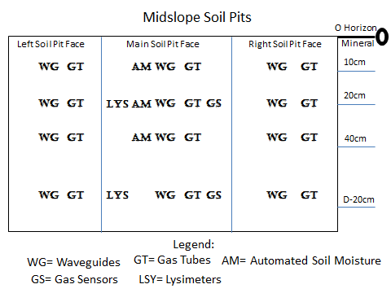
Sites | Shale Hills:  SPMS – South Planar Mid-Slope  Latitude 40.6641998  Longitude -77.9063034
Publications | none
Data Use Notes | The user of Shale Hills Susquehanna CZO data agrees to provide proper acknowledgment with each usage of the data. Citation of the name(s) of the investigator(s) responsible for the data set, in addition to the generic statement above, constitutes proper acknowledgment. Author(s) (including Shale Hills Susquehanna CZO investigators) of published material that makes use of previously unpublished Shale Hills Susquehanna CZO data agree to provide the Shale Hills Susquehanna CZO data manager with four (4) copies (preferably reprints) of that material for binding as soon as it becomes available. The user of Shale Hills Susquehanna CZO data agrees not to resell or redistribute shared data. The user of these data should be aware that, while efforts have been taken to ensure that these data are of the highest quality, there is no guarantee of perfection for the data contained herein and the possibility of errors exists. These data are defined as either public or private, such that a password may be required for access.

