SSHCZO Metadata Worksheet

Data File Name | SH_Well_W7.csv
Date Prepared | 2017-10-19
Descriptive Title | Well 7
Update Frequency | Quarterly
Abstract | Groundwater level data and water temperature for well 7 are measured every 30 minutes 2014-05-19 to 2017-01-19 and changed to every 15 minutes starting 2017-05-31. Data are measured using a HOBO U20-001-01 non-vented pressure transducer. Recorded data began 2014-05-19 through present.
Investigator  Contact Info | Dr. Susan Brantley, Professor of Geosciences, The Pennsylvania State University, 2217 Earth and Environmental Systems Institute, University Park, PA, 16802, 814.865.1619, sxb7@psu.edu.
Data Value Descriptions | - COL1: label = TmStamp_UTC; Timezone = UTC  - COL2: label = WaterTemp_C; water temperature; Units = degC  - COL3: label = WL_BLG_m; water level below ground; Units = meters
Keywords | Groundwater Depth, Groundwater Temperatures, Hydrology
Methods | Groundwater level measurements are recorded every 15 to 30 minutes on a HOBO U20-001-01 non-vented pressure transducer. Data are manually downloaded monthly using HOBO-Ware Pro software. Sensor depth is calculated in the software by processing with barometric pressure data recorded on a separate HOBO U20-001-01 pressure transducer. Water level below ground determined using the suspended cable length to sensor below ground and taking the difference of the SensorDepth_m [WL_BLG_m = 3.45 - SensorDepth_m].  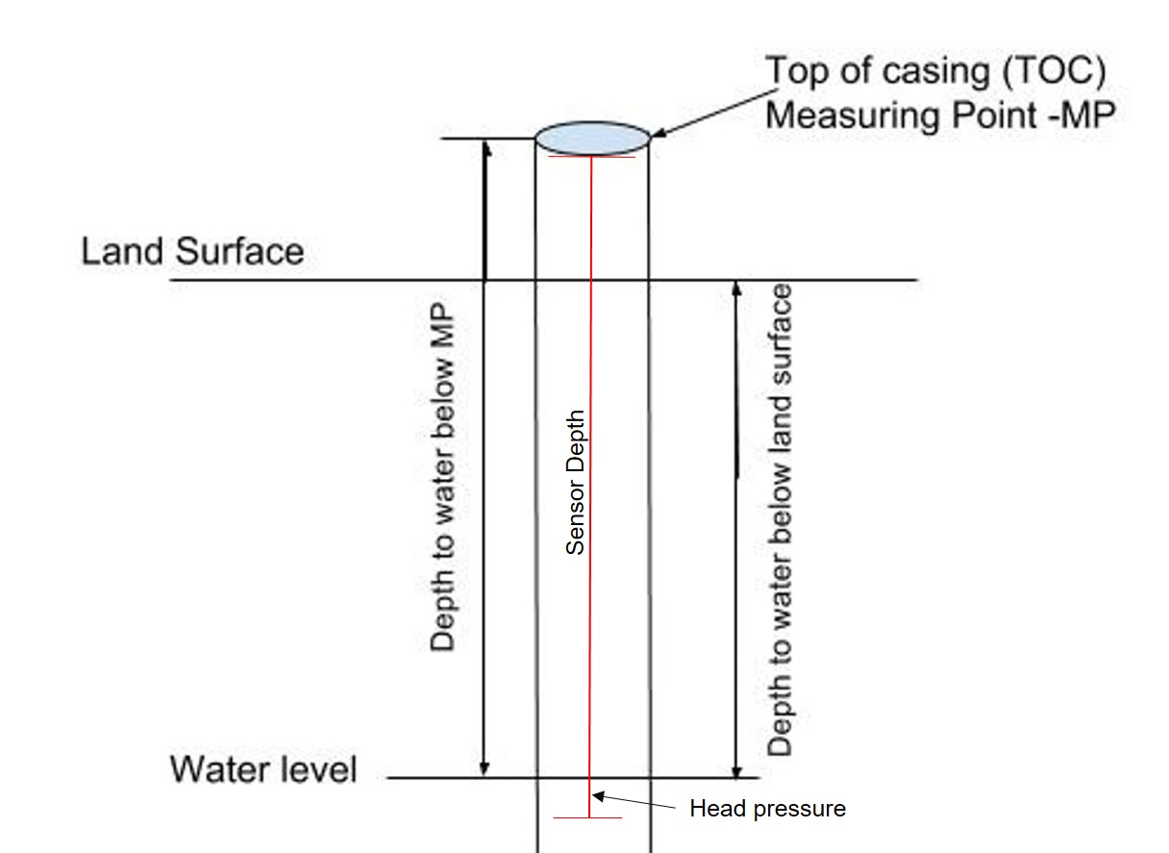  TOC above land surface = 0.44 meters  Sensor level down borehole from MP = 3.15 meters  Sensor below ground level = 2.71 meters  Casing type = pvc  Quality control:  Data were checked by graphing data in R package and comparing to precipitation and manual water level measurements using a Solinist electric tape. Data are corrected to the manual measurements and prorated between visits. Bad, missing, or erroneous data values were removed or marked with -9999 which could be caused during data downloads and/or malfunctioning sensors.  ISCO sampling: Data that fluctuate during autosampler run times remain in the data set for comparison during the actual sample times and for response time evaluations. Periods of autosampler running:  2016-07-16 to 2016-08-14  2016-08-21 to 2016-08-23  2016-09-16  2016-09-29 to 2016-10-05  2016-10-20 to 2016-11-02  2016-11-21 to 2016-12-13  2017-01-01 to 2017-01-13  2017-03-24 to 2017-04-16  Data gaps:  2014-09-23 to 2015-10-27; sensor was filled previously and data were lost  2017-01-19 to 2017-05-31; sensor removed for repair  2018-01-13 to 2018-01-17: values removed; exceeded well depth and overall TOC height  Other notes:  2018-02-06 to 2018-03-09: a 0.49 constant correction was added for this time period due to  Sensor cable found lying partially out of well casing. Length of cable measured was 0.49 meters and corroborated by the raw data.
Sites | Shale Hills Valley northing/easting: 147812.839/ 586833.395; DMS: 40.664444, -77.905712 (NAD_1983_StatePlane_Pennsylvania_South_FIPS_3702); Elevation 265 meters
Publications | none
Citation | The following acknowledgment should accompany any publication or citation of these data: Logistical support and/or data were provided by the NSF-supported Susquehanna Shale Hills Critical Zone Observatory.
Data Use Notes | The user of Susquehanna Shale Hills CZO data agrees to provide proper acknowledgment with each usage of the data. Citation of the name(s) of the investigator(s) responsible for the data set, in addition to the generic statement above, constitutes proper acknowledgment. Author(s) (including Susquehanna Shale Hills CZO investigators) of published material that makes use of previously unpublished Susquehanna Shale Hills CZO data agree to provide the Susquehanna Shale Hills CZO data manager with four (4) copies (preferably reprints) of that material for binding as soon as it becomes available. The user of Susquehanna Shale Hills CZO data agrees not to resell or redistribute shared data. The user of these data should be aware that, while efforts have been taken to ensure that these data are of the highest quality, there is no guarantee of perfection for the data contained herein and the possibility of errors exists. These data are defined as either public or private, such that a password may be required for access.

