SSHCZO Metadata Worksheet

Data File Name | SH_Well_W5.csv
Date Prepared | 2017-10-19
Descriptive Title | Well 5
Update Frequency | Quarterly
Abstract | Groundwater level data and water temperature for well 5 are measured every 15 minutes using a HOBO U20-001-01 non-vented pressure transducer. Recorded data began 2017-05-26 through present.
Investigator  Contact Info | Dr. Susan Brantley, Professor of Geosciences, The Pennsylvania State University, 2217 Earth and Environmental Systems Institute, University Park, PA, 16802, 814.865.1619, sxb7@psu.edu.
Data Value Descriptions | - COL1: label = TmStamp_UTC; Timezone = UTC  - COL2: = WaterTemp_C; water temperature; Units = degC  - COL3: label = WL_BLG_m; adjusted water level below ground; Units = meters
Keywords | Groundwater Depth, Groundwater Temperatures, Hydrology
Methods | Groundwater level measurements are recorded every 15 minutes on a HOBO U20-001-01 non-vented pressure transducer. Data are manually downloaded monthly using HOBO-Ware Pro software. Sensor depths are calculated in the software by processing with barometric pressure data recorded on a separate HOBO U20-001-01 pressure transducer. Manual field measurements are made using a Solinist electric tape to measure water level below ground. These manual measurements are used to apply a prorated correction between visits to create the final water level below ground (WL_BLG_m).  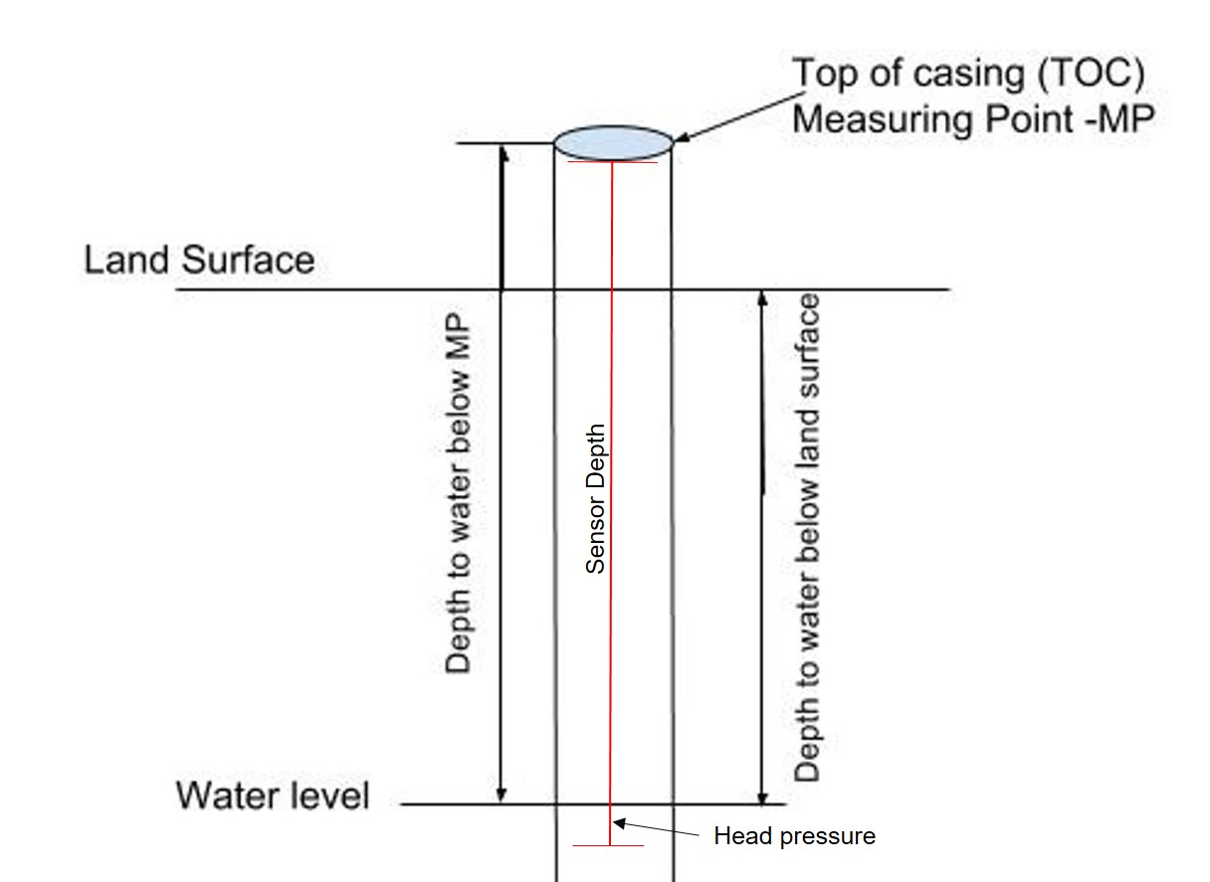  TOC above land surface = 0.22 meters  Sensor location down borehole from MP = 3.90 meters  Sensor location below land surface = 3.68 meters  The water table below land surface is obtained by subtracting the head pressure and above ground casing length from the sensor depth.
Sites | Shale Hills North Swale northing/easting: 147832.854/ 586781.252; DMS: 40.664623, -77.906329 (NAD_1983_StatePlane_Pennsylvania_South_FIPS_3702); Elevation 263.03 meters
Publications | none
Citation | The following acknowledgment should accompany any publication or citation of these data: Logistical support and/or data were provided by the NSF-supported Susquehanna Shale Hills Critical Zone Observatory.
Data Use Notes | The user of Susquehanna Shale Hills CZO data agrees to provide proper acknowledgment with each usage of the data. Citation of the name(s) of the investigator(s) responsible for the data set, in addition to the generic statement above, constitutes proper acknowledgment. Author(s) (including Susquehanna Shale Hills CZO investigators) of published material that makes use of previously unpublished Susquehanna Shale Hills CZO data agree to provide the Susquehanna Shale Hills CZO data manager with four (4) copies (preferably reprints) of that material for binding as soon as it becomes available. The user of Susquehanna Shale Hills CZO data agrees not to resell or redistribute shared data. The user of these data should be aware that, while efforts have been taken to ensure that these data are of the highest quality, there is no guarantee of perfection for the data contained herein and the possibility of errors exists. These data are defined as either public or private, such that a password may be required for access.

