SSHCZO Metadata Worksheet

Data File Name | SH_Well_W11.csv
Date Prepared | 2017-10-19
Descriptive Title | Well 11
Update Frequency | Quarterly
Abstract | Groundwater level data and water temperature for well 11 are measured every 15 minutes using a HOBO U20-001-01 non-vented pressure transducer. Recorded data began 2014-11-13 through present.
Investigator  Contact Info | Dr. Susan Brantley, Professor of Geosciences, The Pennsylvania State University, 2217 Earth and Environmental Systems Institute, University Park, PA, 16802, 814.865.1619, sxb7@psu.edu.
Data Value Descriptions | - COL1: label = TmStamp_UTC; Units = Time Zone UTC  - COL2: label = WaterTemp_C; water temperature; Units = degC  - COL3: label = WL_BLG_m; water level below ground; Units = meters
Keywords | Groundwater Depth, Groundwater Temperatures, Hydrology
Methods | Groundwater level measurements are recorded every 15 minutes on a HOBO U20-001-01 non-vented pressure transducer. Data are manually downloaded monthly using HOBO-Ware Pro software. Sensor depth is calculated in the software by processing with barometric pressure data recorded on a separate HOBO U20-001-01 pressure transducer. Water level below ground determined using the suspended cable length to sensor below ground and taking the difference of the SensorDepth_m [WL_BLG_m = 3.46 - SensorDepth_m].  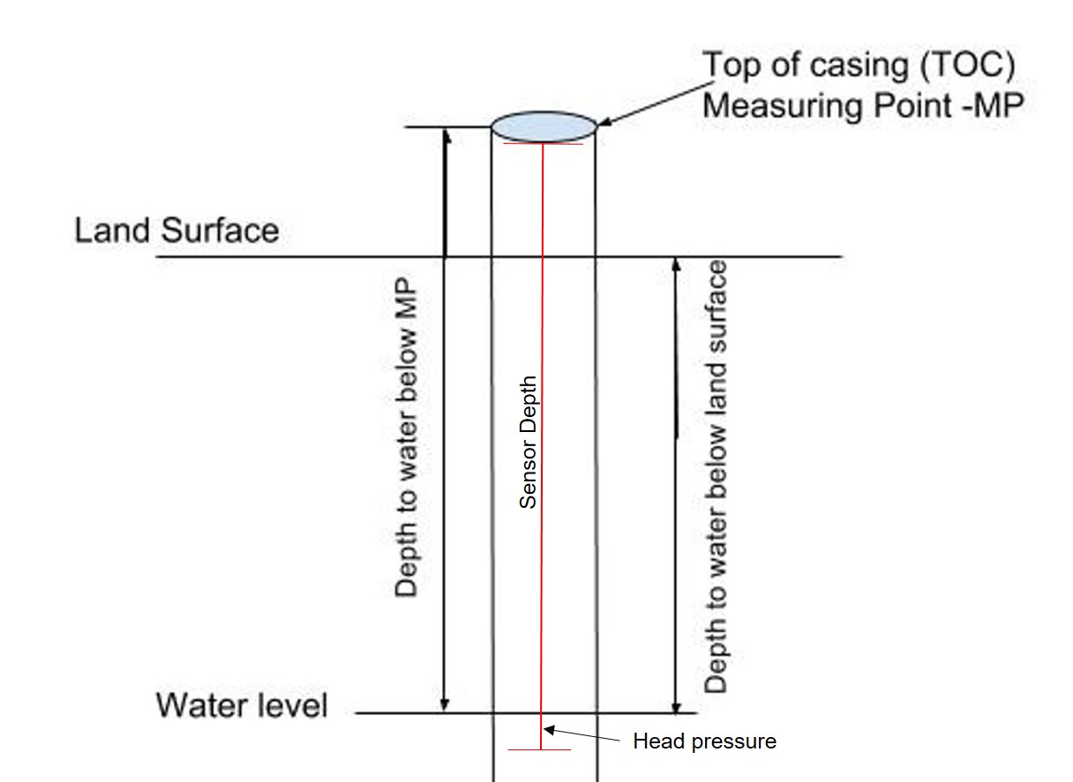  TOC above land surface = 0.53 meters  Sensor level down borehole from MP = 3.98 meters  Sensor level below ground = 3.45 meters  Casing type = pvc  Quality control:  Data were checked by graphing data in R package and comparing to precipitation and manual water level measurements using a Solinist electric tape. Bad, missing, or erroneous data values were removed or marked with -9999 which could be caused during data downloads and/or malfunctioning sensors.  ISCO sampling: Data that fluctuate during autosampler run times remain in the data set for comparison during the actual sample times and for response time evaluations. Periods of known autosampler running or manual sampling:  2016-07-28 to 2016-08-15  2016-08-21 to 2016-08-23  2016-09-16 to 2016-09-17  2016-09-29 to 2016-10-05  2016-10-20 to 2016-11-02  2016-11-21 to 2016-12-13  2017-01-01 to 2017-01-05  2017-01-11 to 2017-01-13  2017-01-17 to 2017-01-30  2017-03-24 to 2017-04-16  2018-08-19: manual sampling  2018-10-14: manual sampling  2019-03-31: manual sampling  2019-04-27: manual sampling  2019-06-03: manual sampling  Other Data gaps:  2014-12-11 to 2014-12-12  2015-03-09  2015-06-27 to 2016-07-28: No sensor was installed  2017-05-26  2017-07-12  2017-08-16  2017-10-24  2018-10-15: sensor maintenance/cleaning  2022-04-08 to 2022-05-17, 2022-06-01 to 2022-06-24: data missing due to sensor being set to record every minute; logger filled up causing logger to stop recording during the gap times. Because of this data corrections were ran across a larger period of time.  Note: Negative values appear due to the water column being above ground within the pvc casing.
Sites | Shale Hills Valley northing/easting: 147848.6787/ 586967.8021; DMS: 40.664769, -77.904123 (NAD_1983_StatePlane_Pennsylvania_South_FIPS_3702); Elevation 270.938
Publications | none
Citation | The following acknowledgment should accompany any publication or citation of these data: Logistical support and/or data were provided by the NSF-supported Susquehanna Shale Hills Critical Zone Observatory.
Data Use Notes | The user of Susquehanna Shale Hills CZO data agrees to provide proper acknowledgment with each usage of the data. Citation of the name(s) of the investigator(s) responsible for the data set, in addition to the generic statement above, constitutes proper acknowledgment. Author(s) (including Susquehanna Shale Hills CZO investigators) of published material that makes use of previously unpublished Susquehanna Shale Hills CZO data agree to provide the Susquehanna Shale Hills CZO data manager with four (4) copies (preferably reprints) of that material for binding as soon as it becomes available. The user of Susquehanna Shale Hills CZO data agrees not to resell or redistribute shared data. The user of these data should be aware that, while efforts have been taken to ensure that these data are of the highest quality, there is no guarantee of perfection for the data contained herein and the possibility of errors exists. These data are defined as either public or private, such that a password may be required for access.

