SSHCZO Metadata Worksheet

Data File Name | SH_CZMW5.csv
Date Prepared | 2017-12-05
Descriptive Title | CZMW 5
Update Frequency | Annually
Abstract | CZMW 5 was drilled in 2012 using a rotary air. The well is cased to 8 meters with 5 cm diameter pvc and slotted for the bottom 1 meter.  Groundwater level data and water temperature for CZMW 5 are measured every 15 minutes from 2017-02-14 to present using a HOBO U20-001-01 non-vented pressure transducer.
Investigator  Contact Info | Dr. Susan Brantley, Professor of Geosciences, The Pennsylvania State University, 2217 Earth and Environmental Systems Institute, University Park, PA, 16802, 814.865.1619, sxb7@psu.edu.
Data Value Descriptions | - COL1: label = TmStamp_UTC; units = UTC  - COL2: label = WaterTemp_C; Units = degC  - COL3: label = WL_BLG_m; water level below ground; Units = meters
Keywords | Groundwater Depth, Groundwater Temperatures, Hydrology
Methods | Groundwater level measurements are currently set to be recorded every 15 minutes on a HOBO U20-001-01 non-vented pressure transducer. Data are manually downloaded monthly using HOBO-Ware Pro software. Sensor depth is calculated in the software by processing with barometric pressure data recorded on a separate HOBO U20-001-01 pressure transducer. Water level below ground determined using the suspended cable length to sensor below ground and taking the difference of the SensorDepth_m [WL_BLG_m = 7.62 - SensorDepth_m].  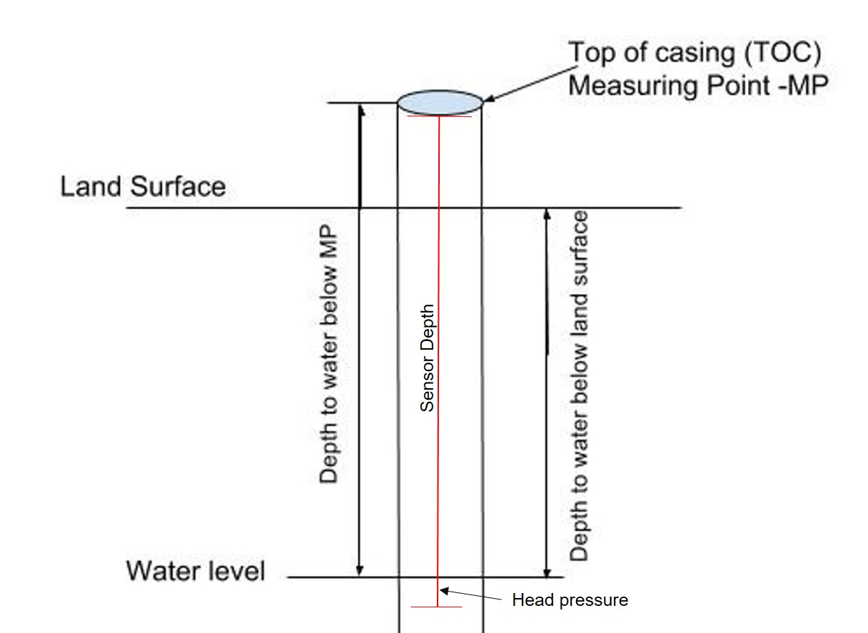  Casing type = pvc  TOC above land surface = 0.12 meters  Sensor location down borehole from TOC = 7.62 meters  Sensor location from ground level = 7.5 meters  Quality control:  Data were checked by analyzing and graphing data in R package and comparing to precipitation and manual water level measurements using a Solinist electric tape. WL_BLG_m data are adjusted for sensor drift by comparison of the manual measurements. Bad, missing, or erroneous data values were removed or marked with -9999 which could be caused during data downloads and/or malfunctioning sensors.  The water level/water table appears to be perched and actual water level is minimal. Due to this, numerous values are marked -9999 for the sensor being out of water.  Data Gaps:  2018-01-14 to 2018-01-17: water level below sensor – data removed  2019-10-14 to 2019-11-19: water level below sensor – data removed  2021-12-20 to 2022-02-21: sensor interval reset; no data  2022-02-21 to 2022-03-24: sensor interval issues again little data  2022-03-24 to 2022-05-17: no data; sensor failure
Sites | Shale Hills northing/easting: 147968.3494/ 586997.7358; DMS: 40.6658, -77.9038(NAD_1983_StatePlane_Pennsylvania_South_FIPS_3702)
Publications | none
Citation | The following acknowledgment should accompany any publication or citation of these data: Logistical support and/or data were provided by the NSF-supported Susquehanna Shale Hills Critical Zone Observatory.
Data Use Notes | The user of Susquehanna Shale Hills CZO data agrees to provide proper acknowledgment with each usage of the data. Citation of the name(s) of the investigator(s) responsible for the data set, in addition to the generic statement above, constitutes proper acknowledgment. Author(s) (including Susquehanna Shale Hills CZO investigators) of published material that makes use of previously unpublished Susquehanna Shale Hills CZO data agree to provide the Susquehanna Shale Hills CZO data manager with four (4) copies (preferably reprints) of that material for binding as soon as it becomes available. The user of Susquehanna Shale Hills CZO data agrees not to resell or redistribute shared data. The user of these data should be aware that, while efforts have been taken to ensure that these data are of the highest quality, there is no guarantee of perfection for the data contained herein and the possibility of errors exists. These data are defined as either public or private, such that a password may be required for access.

