SSHCZO Metadata Worksheet

Data File Name | SH_CZMW11.csv
Date Prepared | 2020-01-29
Descriptive Title | CZMW 11
Update Frequency | Quarterly
Abstract | CZMW 11 was drilled on 2019-06-19 by parratt wolff inc using a CME 850X crawler mounted direct push/rotary drill rig. 6 ¼ in augers were used to drill to refusal at 5.334 meters and a 6” air hammer was used to continue to 5.944 meters. The well is cased to 5.944 meters with 4” pvc casing. Boring continued with a 4” air hammer to a depth of 44.196 meters.  CZMW 11 is continuously monitored using a vented Meter Environment HYDROS 21 sensor. The sensor measures depth, water temperature, and conductivity (CTD). Measurements are made every 3 minutes, averaged, and are recorded every 15 minutes to a Campbell Scientific CR1000 data logger. The logger is programed and calibrated to manual water level measurements below ground. If changes are made in the offset between top of casing (TOC) and water level, the program will automatically store the old offset after the new offset is entered. A Campbell Scientific Dissolved Oxygen sensor is also installed.  Data are reviewed and QA’ed quarterly. The QA process is accomplished using precipitation data, other nearby well data, and manual water level measurements. Manual water level measurements are made periodically Solinist Electric Well tape and recorded in a spreadsheet.
Investigator  Contact Info | Dr. Susan Brantley, Professor of Geosciences, The Pennsylvania State University, 2217 Earth and Environmental Systems Institute, University Park, PA, 16802, 814.865.1619, sxb7@psu.edu.
Data Value Descriptions | - COL1: label = TmStamp_UTC; Timezone = UTC  - COL2: label = WaterTem_pC; averaged water temperature; Units = degC  - COL3: label = WL_BLG_m; Corrected and averaged water level below the ground surface; Units = meters  - COL4: label = Cond; Specific Conductance, Units = uS/cm  - COL5: label = DOmv; millivolts for raw Dissolved Oxygen levels; Units = mv  - COL6: label = DOppm; Dissolved Oxygen in parts per million; Units = ppm  - COL7: label = DOppm_Avg = averaged 15 min DO ppm; Units = ppm
Keywords | Groundwater Depth, Groundwater Temperatures, Hydrology
Methods | Groundwater level measurements are recorded every 15 minutes with a vented METER Environment HYDROS 21 sensor (previously Decagon CTD) wired to a Campbell Scientific CR1000 data logger. Data are streamed to campus via Ethernet and fiber optic connections to the University network.  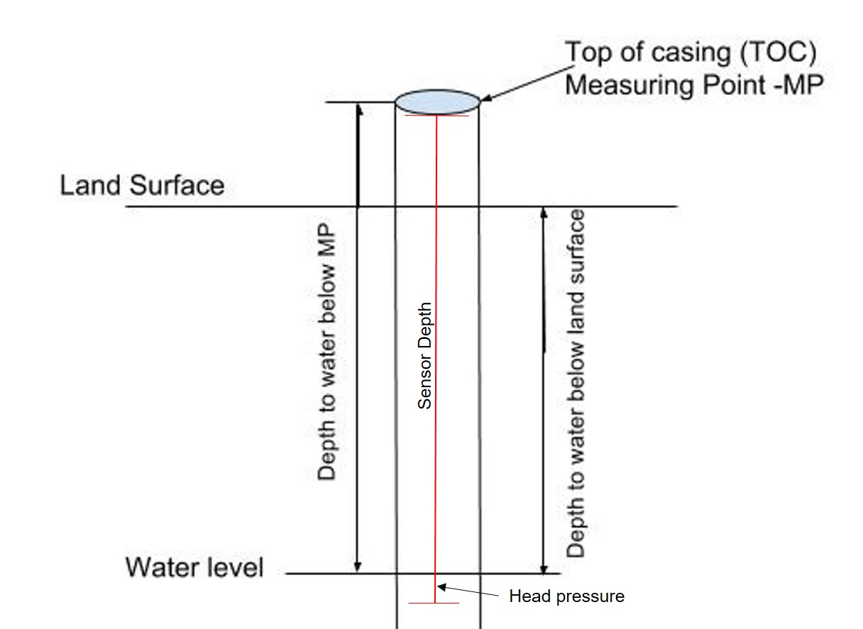  TOC above land surface = 0.44 meters  Sensor location down borehole from TOC = 18.44 meters  Sensor location from ground level = 18.00 meters  WL_BLG_m is measured with the in-situ sensor by recording the water pressure and known distance to the ground surface resulting in the actual water level below ground in meters. The manual measurements using the well tape are used to verify and correct the data. Corrections are applied when the manual well measurements are different from what is recorded by the sensor. The difference between the sensor data and manual data is applied and prorated visit to visit.  SpC values are QA’ed and corrected to calibrated YSI data by comparing sensor data to the YSI data and applying the difference. These corrections are prorated visit to visit.  Data Gaps/Issues:  2019-08-08 to 2019-09-23: data removed due to improper program being used  2019-10-21 to 2019-10-23; sensors removed while doing down hole geophysics work  2022-08-09: logger replaced with a CR1000X due to ethernet module failure – rec numbers started over and data recovered from older logger
Sites | Shale Hills Valley: 40.66380, -77.90610(NAD_1983_StatePlane_Pennsylvania_South_FIPS_3702)
Publications | none
Citation | The following acknowledgment should accompany any publication or citation of these data: Logistical support and/or data were provided by the NSF-supported Susquehanna Shale Hills Critical Zone Observatory.
Data Use Notes | The user of Susquehanna Shale Hills CZO data agrees to provide proper acknowledgment with each usage of the data. Citation of the name(s) of the investigator(s) responsible for the data set, in addition to the generic statement above, constitutes proper acknowledgment. Author(s) (including Susquehanna Shale Hills CZO investigators) of published material that makes use of previously unpublished Susquehanna Shale Hills CZO data agree to provide the Susquehanna Shale Hills CZO data manager with four (4) copies (preferably reprints) of that material for binding as soon as it becomes available. The user of Susquehanna Shale Hills CZO data agrees not to resell or redistribute shared data. The user of these data should be aware that, while efforts have been taken to ensure that these data are of the highest quality, there is no guarantee of perfection for the data contained herein and the possibility of errors exists. These data are defined as either public or private, such that a password may be required for access.

