SSHCZO Metadata Worksheet

Data File Name | SH_CZMW10.csv
Date Prepared | 2018-03-09
Descriptive Title | CZMW 10
Update Frequency | Quarterly
Abstract | CZMW 10 was drilled on 2017-11-21 using an Acker Soil Scout® Track Mounted Drill Rig by Mountain Research, LLC. A direct push drilling method was used to collect overburden soil from 0 to 10 feet (0 to 3.05 meters) below ground surface. A 6.25 inch inner diameter HSA was used to auger from 0 to 3.05 meters. A Mission SD 6 inch diameter down-hole pneumatic driven rotary percussion hammer was used to drill from 10.0 to 40.0 feet (3.05 to 12.19 meters). Competent rock was observed about 30 feet (9.14 meters) below ground surface. 4 inch inner diameter PVC/riser casing was installed and sealed with 5 50 pound bags of 3/8 inch bentonite chips (Halliburton Baroid Industrial Drilling Products).  CZMW10 well was completed using an air rotary Mission SD 4 inch diameter down-hole pneumatic driven rotary percussion hammer from 40 to 115.0 feet (12.19 to 35.05 meters). The completed well is 4 inch diameter open bedrock borehole from 40 to 115.0 feet (12.19 to 35.05 meters).  CZMW_10 is continuously monitored using a vented Meter Environment HYDROS 21 sensor. The sensor measures depth, water temperature, and conductivity (CTD). Measurements are made every 3 minutes, averaged, and are recorded every 15 minutes to a Campbell Scientific CR1000 data logger. The logger is programed and calibrated to manual water level measurements below ground. If changes are made in the offset between top of casing (TOC) and water level, the program will automatically store the old offset after the new offset is entered.  Data are reviewed and QA’ed quarterly. The QA process is accomplished using precipitation data, other nearby well data, and manual water level measurements. Manual water level measurements are made periodically Solinist Electric Well tape and recorded in a spreadsheet.
Investigator  Contact Info | Dr. Susan Brantley, Professor of Geosciences, The Pennsylvania State University, 2217 Earth and Environmental Systems Institute, University Park, PA, 16802, 814.865.1619, sxb7@psu.edu.
Data Value Descriptions | - COL1: label = TmStamp; Timezone = UTC  - COL2: label = WL_BLG_m; Units = meters; Corrected water level below ground  - COL3: label = WaterTemp_C; Averaged; Units = degC  - COL4: label = Spc_Cond; Units = uS/cm
Keywords | Groundwater Depth, Groundwater Temperatures, Hydrology
Methods | Groundwater level measurements are recorded every 15 minutes with a vented METER Environment HYDROS 21 sensor (previously Decagon CTD) wired to a Campbell Scientific CR1000 data logger. Data are streamed to campus via Ethernet and fiber optic connections to the University network.  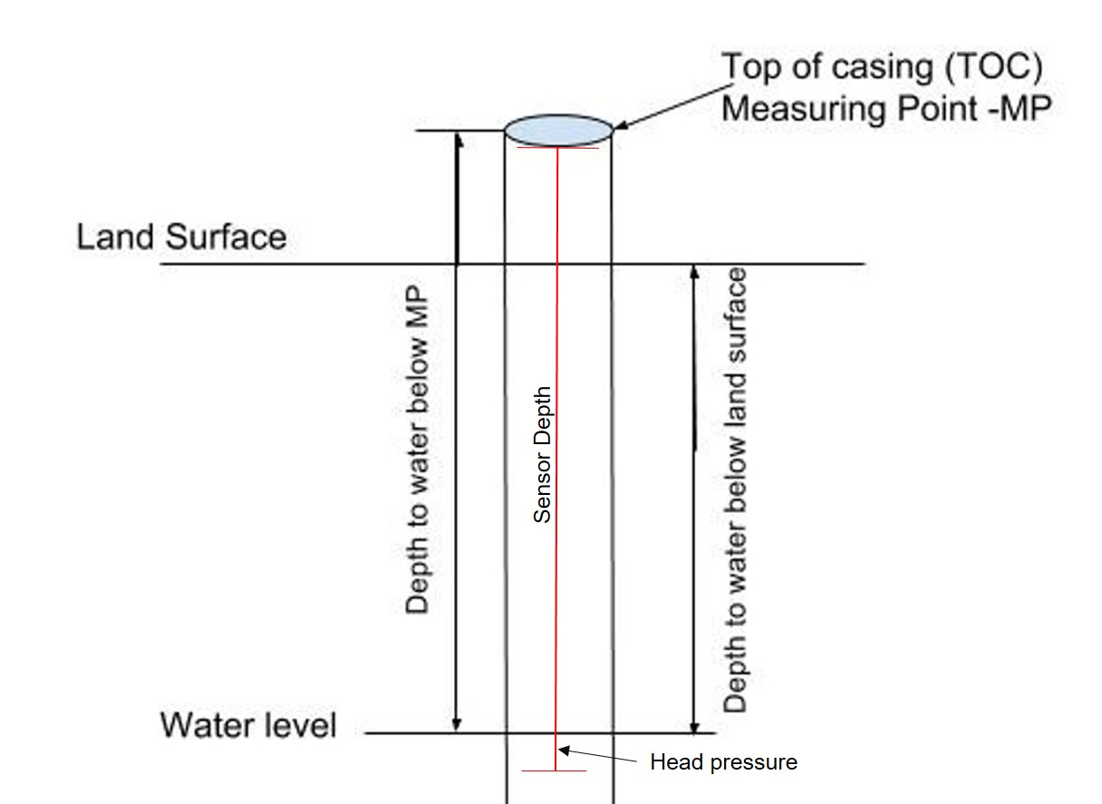  TOC above land surface = 0.29 meters  Sensor location down borehole from TOC = 7.00 meters  Sensor location from ground level = 6.71 meters  WL_BLG_m is measured with the in-situ sensor by recording the water pressure and known distance to the ground surface resulting in the actual water level below ground in meters. The manual measurements using the well tape are used to verify and correct the data. Corrections are applied when the manual well measurements are different from what is recorded by the sensor. The difference between the sensor data and manual data is applied and prorated visit to visit.  Conductance values are converted to Specific Conductance ) (SpC) using the following formula:  ([Cond]/((1)+(0.0191)*([WaterTemp_C]-(25))))  SpC values are QA’ed and corrected to calibrated YSI data by comparing sensor data to the YSI data and applying the difference. These corrections are prorated visit to visit.  Data Gaps/Issues:  2018-02-23 to 2018-03-15: sensor broken and was removed for repair
Sites | Shale Hills Valley: 40.66477, -77.90712(NAD_1983_StatePlane_Pennsylvania_South_FIPS_3702)
Publications | none
Citation | The following acknowledgment should accompany any publication or citation of these data: Logistical support and/or data were provided by the NSF-supported Susquehanna Shale Hills Critical Zone Observatory.
Data Use Notes | The user of Susquehanna Shale Hills CZO data agrees to provide proper acknowledgment with each usage of the data. Citation of the name(s) of the investigator(s) responsible for the data set, in addition to the generic statement above, constitutes proper acknowledgment. Author(s) (including Susquehanna Shale Hills CZO investigators) of published material that makes use of previously unpublished Susquehanna Shale Hills CZO data agree to provide the Susquehanna Shale Hills CZO data manager with four (4) copies (preferably reprints) of that material for binding as soon as it becomes available. The user of Susquehanna Shale Hills CZO data agrees not to resell or redistribute shared data. The user of these data should be aware that, while efforts have been taken to ensure that these data are of the highest quality, there is no guarantee of perfection for the data contained herein and the possibility of errors exists. These data are defined as either public or private, such that a password may be required for access.

