SSHCZO Metadata Worksheet

Data File Name | SH_CZMW10.csv
Date Prepared | 2018-03-09
Descriptive Title | CZMW 10
Update Frequency | Continuous
Abstract | CZMW 10 was drilled on 2017-11-21 using an Acker Soil Scout® Track Mounted Drill Rig by Mountain Research, LLC. A direct push drilling method was used to collect overburden soil from 0 to 10 feet (0 to 3.05 meters) below ground surface. A 6.25 inch inner diameter HSA was used to auger from 0 to 3.05 meters. A Mission SD 6 inch diameter down-hole pneumatic driven rotary percussion hammer was used to drill from 10.0 to 40.0 feet (3.05 to 12.19 meters). Competent rock was observed about 30 feet (9.14 meters) below ground surface. 4 inch inner diameter PVC/riser casing was installed and sealed with 5 50 pound bags of 3/8 inch bentonite chips (Halliburton Baroid Industrial Drilling Products).  CZMW10 well was completed using an air rotary Mission SD 4 inch diameter down-hole pneumatic driven rotary percussion hammer from 40 to 115.0 feet (12.19 to 35.05 meters). The completed well is 4 inch diameter open bedrock borehole from 40 to 115.0 feet (12.19 to 35.05 meters).  CZMW_10 is continuously monitored using a vente Meter Environment HYDROS 21 sensor. The sensor measures depth, water temperature, and conductivity (CTD). Measurements are made every 3 minutes, averaged, and are recorded every 15 minutes to a Campbell Scientific CR1000 data logger. The logger is programed and calibrated to manual water level measurements below ground. If changes are made in the offset between top of casing (TOC) and water level, the program will automatically store the old offset after the new offset is entered.
Investigator  Contact Info | Dr. Susan Brantley, Professor of Geosciences, The Pennsylvania State University, 2217 Earth and Environmental Systems Institute, University Park, PA, 16802, 814.865.1619, sxb7@psu.edu.
Data Value Descriptions | - COL1: label = TmStamp; Timezone = UTC  - COL2: label = RecNum; internal logger reference  - COL3: label = WtrGrnLvlCrctd_m_Avg; Units = meters; Corrected water level below ground  - COL4: label = Water_TempC_Avg; Units = degC  - COL5: label = Cond_Avg, Units uS/cm
Keywords | Groundwater Depth, Groundwater Temperatures, Hydrology
Methods | Groundwater level measurements are recorded every 15 minutes with a vented METER Environment HYDROS 21 sensor (previously Decagon CTD) wired to a Campbell Scientific CR1000 data logger. Data are streamed to campus via Ethernet and fiber optic connections to the University network.  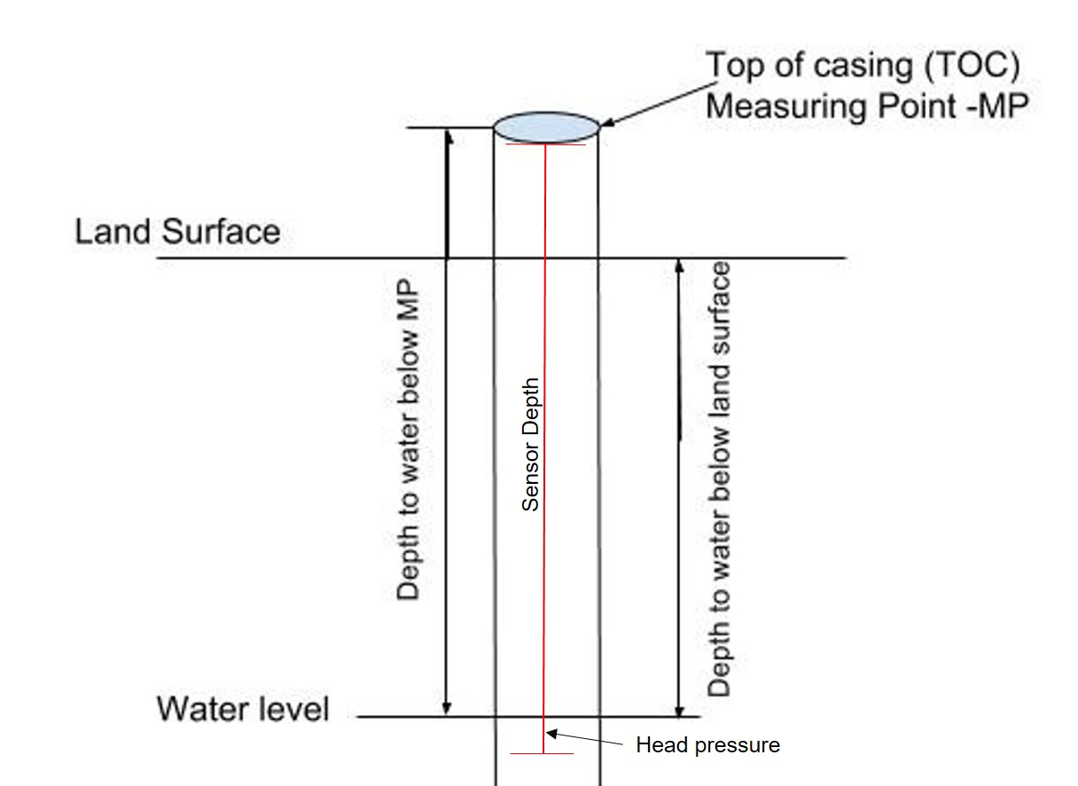  TOC above land surface = 0.29 meters  Sensor location down borehole from TOC = 7.00 meters  Sensor location from ground level = 6.71 meters  The water table below land surface is measured by subtracting the head pressure and above ground casing length from the sensor depth.
Sites | Shale Hills Valley: 40.66477, -77.90712(NAD_1983_StatePlane_Pennsylvania_South_FIPS_3702)
Publications | none
Citation | The following acknowledgment should accompany any publication or citation of these data: Logistical support and/or data were provided by the NSF-supported Susquehanna Shale Hills Critical Zone Observatory.
Data Use Notes | The user of Susquehanna Shale Hills CZO data agrees to provide proper acknowledgment with each usage of the data. Citation of the name(s) of the investigator(s) responsible for the data set, in addition to the generic statement above, constitutes proper acknowledgment. Author(s) (including Susquehanna Shale Hills CZO investigators) of published material that makes use of previously unpublished Susquehanna Shale Hills CZO data agree to provide the Susquehanna Shale Hills CZO data manager with four (4) copies (preferably reprints) of that material for binding as soon as it becomes available. The user of Susquehanna Shale Hills CZO data agrees not to resell or redistribute shared data. The user of these data should be aware that, while efforts have been taken to ensure that these data are of the highest quality, there is no guarantee of perfection for the data contained herein and the possibility of errors exists. These data are defined as either public or private, such that a password may be required for access.

