SSHCZO Metadata Worksheet

Data File Name | HV_3_well_level_1.csv
Date Prepared | 2018-06-27
Descriptive Title | Harrys Valley Well 3 (HV3)
Update Frequency | Quarterly
Abstract | Groundwater level data for Harrys Valley 3 meter well were measured every 10 minutes from 2016-06-15 to 2016-10-06 and 15 minutes from 2017-01-18 to present using a HOBO non-vented pressure transducer and processed with a HOBO pressure transducer that recorded barometric pressure. Recorded data began 2016-06-15 through present.
Investigator  Contact Info | Dr. Tess Russo, – Assistant Professor, Department of Geosciences, 310 Deike Building, Pennsylvania State University, University Park, PA 16802, russo@psu.edu, (814)865-7389  Beth Hoagland, neh137@psu.edu, Graduate Student, 502-432-0755
Data Value Descriptions | - COL1: label = TmStamp_UTC; TimeZone = UTC  - COL2: label = water_temp_C; Units = degC, water temperature  - COL3: label = air_pres_kPa; Units = kPa  - COL4: label = WL_BLG_m; Units = meters
Keywords | Hydrology, groundwater level, groundwater temperature
Methods | Groundwater level data far Harrys Valley 3 meter well were measured every 10 minutes from 2016-06-15 to 2016-10-06 and 15 minutes from 2017-01-18 to present using a HOBO non-vented pressure transducer and processed with a HOBO pressure transducer that recorded barometric pressure. Data were processed using barometric values from a HOBO data logger located nearby (40.692454 - 77.927731). HoboWare Pro software is used to download these sensors and process these data. Manual field measurements are made using a Solinist electric tape to measure water level below ground. These manual measurements are used to apply a prorated correction between visits to create the final water level below ground (WL_BLG_m).  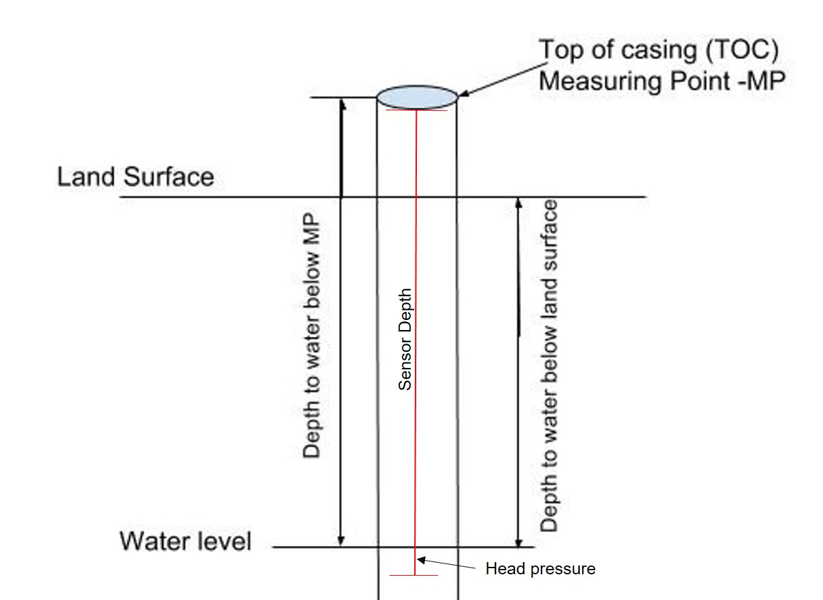  TOC above land surface = 0.41 meters  Sensor location down borehole from TOC = 1.25  Sensor location below land surface = 0.82 meters  -9999 values indicate missing erroneous data during downloads or sensor malfunctions.  Gaps, missing, or erroneous data:  2016-10-06 to 2017-01-18: sensor removed for repair
Sites | Garner Run (Rothrock State Forest) 40.692454 - 77.927731, elevation 465m
Citation | The following acknowledgment should accompany any publication or citation of these data: Logistical support and/or data were provided by the NSF-supported Shale Hills Susquehanna Critical Zone Observatory.
Publications | Unpublished, please embargo public access to this dataset.
Data Use Notes | The user of Shale Hills Susquehanna CZO data agrees to provide proper acknowledgment with each usage of the data. Citation of the name(s) of the investigator(s) responsible for the data set, in addition to the generic statement above, constitutes proper acknowledgment. Author(s) (including Shale Hills Susquehanna CZO investigators) of published material that makes use of previously unpublished Shale Hills Susquehanna CZO data agree to provide the Shale Hills Susquehanna CZO data manager with four (4) copies (preferably reprints) of that material for binding as soon as it becomes available. The user of Shale Hills Susquehanna CZO data agrees not to resell or redistribute shared data. The user of these data should be aware that, while efforts have been taken to ensure that these data are of the highest quality, there is no guarantee of perfection for the data contained herein and the possibility of errors exists. These data are defined as either public or private, such that a password may be required for access.

