SSHCZO Metadata Worksheet

Data File Name | CF_COSMOS_All.csv
Date Prepared | 2020-06-29
Descriptive Title | Cole Farm COSMOS Level 0, 1, 2 data
Update Frequency | Hourly
Abstract | Hydroinnova Cosmic-Ray Soil Moisture/Snow Sensing System (COSMOS), Model CRS-1000/B, non-invasively measures moderated neutron count among an averaged area (around 700 meters in diameter (Franz et al., 2013)), which can indirectly represent soil moisture in the top 50 cm of soil. This file includes level 0 (raw) data measured directly from COSMOS. The neutron count can be affected by various elements in surroundings, where hydrogen is often the dominant one (Zreda et al., 2012). The neutron rate counted by the MOD column of COSMOS therefore can be used to determine soil moisture after a standard correction and point calibration, the results of which are COSMOS Level 2 and Level 3 data.
Investigator  Contact Info | Dr. Li Li, Associate Professor, Department of Energy and Mineral Engineering, The Pennsylvania State University, 154 Hosler Building, University Park, PA 16802, (814)867-3547  lili@eme.psu.edu  Dacheng Xiao, PhD student, Department of Energy and Mineral Engineering, The Pennsylvania State University, 228 Hosler Building, University Park, PA 16802, (814)777-6006  dzx102@psu.edu
Data Value Descriptions | Level 0  - COL1: label = UTC; Time zone=UTC, neutron count interval.  - COL2: label = N1[cph]; neutron counts per hour for Moderated detector  - COL3: label = N2[cph]; neutron counts per hour for Bare detector  - COL4: label = T1[C]; Unit = degree centigrade, the temperature inside the logger  - COL5: label = P1[mb]; Unit = mb; backup pressure (internal)  - COL6: label = Batt[V}; Unit = V, battery voltage  - COL7: label = H7[%]; Unit = relative humidity, percent; outside sensor  - COL8: label = P4[mb]; Unit = mb, barometric pressure inside data logger box  - COL9: label = T7[C]; Unit = degree centigrade; outside sensor  - COL10: label = NMcounts; counting rate of Jungfrau neutron monitor  - COL11: label = fbar; pressure correction factor based pressure (COL7-P4)  - COL12: label = fhum; humidity correction factor based temperature (COL8- T7) and relative humidity (COL6 – H7)  - COL13: label = fsol; solar correction factor based on the NMcounts (COL9)  - COL14: label = CR VWC; calculated volume water content on HydroInnova server
Keywords | COSMOS, Soil Moisture
Methods | The COSMOS unit was installed on August 20, 2018. Soil samples for calibration were collected on September 4, 2018. Data are collected using Hydroinnova Cosmic-Ray Soil Moisture/Snow Sensing System. Data are transmitted via iridium satellite telemetry to the Hydroinnova servers on a hourly rate. Data are then transferred to the CZO database via CRON job that runs twice per day. Data processing for obtaining soil moisture is completed in R. See below for the process:  Raw data needed  N1Cts (MOD,cph, Level 0 data), Pressure (P, mb), Absolute humidity ($ρ_{v0}$), Neutron intensity (or INTEN, described in Correction section)  Correction and Level 1 data  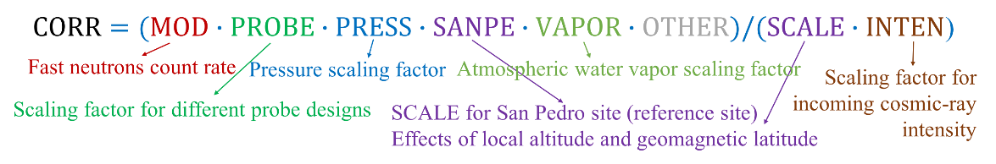 Eq (1)  WHERE:  MOD = N1Cts;  PROBE = 1 (for SH and GR), and 0.5 (for CF);  PRESS = $exp⁡(\frac{P_{0}-P}{L})$; L = 133, P0 = 956 (for all sites);  SANPE = 2.486;  VAPOR = $1+0.0054*(ρ_{v0}-ρ_{v0}^{ref})$;  OTHER = 1;  SANPE = 2.654;  INTEN = I_{m}/I₀; I_{m} = measured neutron monitor intensity; I₀ = reference intensity;  CORR = Corrected MOD data (level 1 data, N or $ϕ$ in Calibration section).  Calibrated parameters and Level 2 data  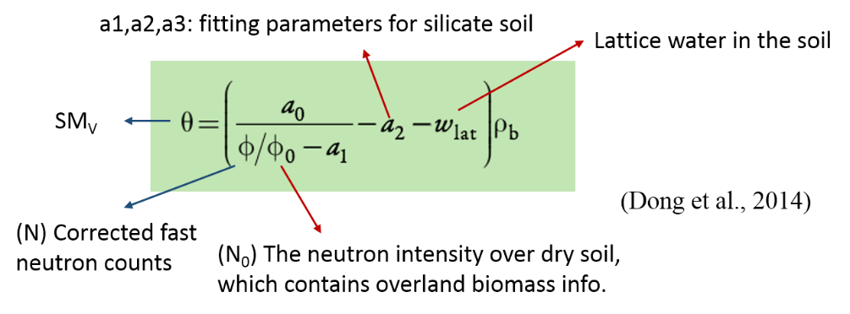 Eq (2)  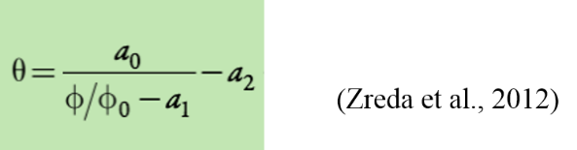 Eq (3)  (Eq 3 is used for the old data processing in SH and GR)  WHERE  $a_{0}= 0.0808; a_{1}= 0.372; a_{2}= 0.115;$  $ω_{lat}=$0.040 g/g (for GR), and 0.048 g/g (for CF);  $ρ_{b}=$0.81 g/cm³ (for GR), and 0.77 g/cm³ (for CF);  $θ_{c} (averaging 108 simples by oven methed)=$0.1771 (for GR), and 0.234(for CF);  Time for $θ_{c}$ GR: 6/25/2015 9:00 – 14:00 (EDT); CF: 9/4/2018 8:45 -14:10 (EDT);  $ϕ_{c} (averaging counts during simpling 108 simples)=$1963.229 (for GR), and 487.7 (for CF);  - Replace $ϕ$ and $θ$ in Eq 2 or 3 using $θ_{c}$ and $ϕ_{c}$ for calculating $ϕ_{0}$;  $ϕ_{0}=$3335.76 (for GR), and 797.65 (for CF) in Eq 2;  $ϕ_{0}=$3026.79 (for GR), and 808.02 (for CF) in Eq 3;  - Using Eq 2 or 3 to calculate $θ$(Level 2) using $ϕ$ at a certain time point
Sites | Cole Farm COSMOS: WGS84, Lat 40.63594; Lon -77.94245
Publications | The data has not yet been published.
Citation | The following acknowledgment should accompany any publication or citation of these data: Financial Support was provided by National Science Foundation Grant EAR – 0725019 (C. Duffy), EAR – 1239285 (S. Brantley), and EAR – 1331726 (S. Brantley) for the Susquehanna Shale Hills Critical Zone Observatory. Logistical support and/or data were provided by the NSF-supported Susquehanna Shale Hills Critical Zone Observatory. This research was conducted on a farm in Shaver's Creek watershed at the intersection of RT 305 and Winchester Road.
Data Use Notes | The user of Susquehanna Shale Hills CZO data agrees to provide proper acknowledgment with each usage of the data. Citation of the name(s) of the investigator(s) responsible for the data set, in addition to the generic statement above, constitutes proper acknowledgment. Author(s) (including Susquehanna Shale Hills CZO investigators) of published material that makes use of previously unpublished Susquehanna Shale Hills CZO data agree to provide the Susquehanna Shale Hills CZO data manager with four (4) copies (preferably reprints) of that material for binding as soon as it becomes available. The user of Susquehanna Shale Hills CZO data agrees not to resell or redistribute shared data. The user of these data should be aware that, while efforts have been taken to ensure that these data are of the highest quality, there is no guarantee of perfection for the data contained herein and the possibility of errors exists. These data are defined as either public or private, such that a password may be required for access.  1. Use our data freely. All CZO Data Products* except those labelled Private** are released to the public and may be freely copied, distributed, edited, remixed, and built upon under the condition that you give acknowledgement as described below. Non-CZO data products — like those produced by USGS or NOAA — have their own use policies, which should be followed.  2. Give proper citation and acknowledgement. Publications, models and data products that make use of these datasets must include proper citation and acknowledgement. Most importantly, provide a citation in a similar way as a journal article (i.e. author, title, year of publication, name of CZO “publisher”, edition or version, and URL or DOI access information. See http://www.datacite.org/whycitedata). Also include at least a brief acknowledgement such as: “Data were provided by the NSF-supported Southern Sierra Critical Zone Observatory” (replace with the appropriate observatory name).  3. Let us know how you will use the data. The dataset creators would appreciate hearing of any plans to use the dataset. Consider consultation or collaboration with dataset creators.  *CZO Data Products. Defined as a data collected with any monetary or logistical support from a CZO.  **Private. Most private data will be released to the public within 1-2 years, with some exceptionally challenging datasets up to 4 years. To inquire about potential earlier use, please contact us.

