SSHCZO Metadata Worksheet

Data File Name | CF_CFW_9.csv
Date Prepared | 2018-11-09
Descriptive Title | CFW_9: Cole Farm Well 9
Update Frequency | Quarterly
Abstract | Groundwater level data and water temperature for CFW_9 measured every 15 minutes using a Van Essen micro-diver non-vented pressure transducer from 2018-10-09 to present. Sensor level during this period is set to 4.1 meters below ground level.
Investigator  Contact Info | Dr. Susan Brantley, Professor of Geosciences, The Pennsylvania State University, 2217 Earth and Environmental Systems Institute, University Park, PA, 16802, 814.865.1619, sxb7@psu.edu.  Dr. Jonathan M. Duncan, Assistant Professor of Hydrology, The Pennsylvania State University, Department of Ecosystem Science & Management, jmduncan@psu.edu
Data Value Descriptions | - COL1: label = TmStamp_UTC; Timezone = Coordinated Universal Time  - COL2: label = WaterTemp_C; water temperature; Units = degC  - COL3: label = WL_BLG_m; water level below ground; Units = meters
Keywords | Groundwater Depth, Groundwater Temperatures, Hydrology
Methods | The monitoring well was drilled on 2018-08-06 with a Shaw BackPack Drill using 51mm diameter diamond bit. The well was drilled to a depth of 4.3 meters. Groundwater level measurements are recorded every 15 minutes on a Van Essen non-vented pressure transducer. Data are manually downloaded monthly using Diver Office 2018.2 software. Continuous water level depths are calculated in the software by processing the well sensor data with barometric pressure data recorded on a separate Van Essen Baro transducer. Manual water level measurements are entered into the software which is used in the process to calculate the water level below the ground surface. Manual measurements are made with a Solinist electric well tape.  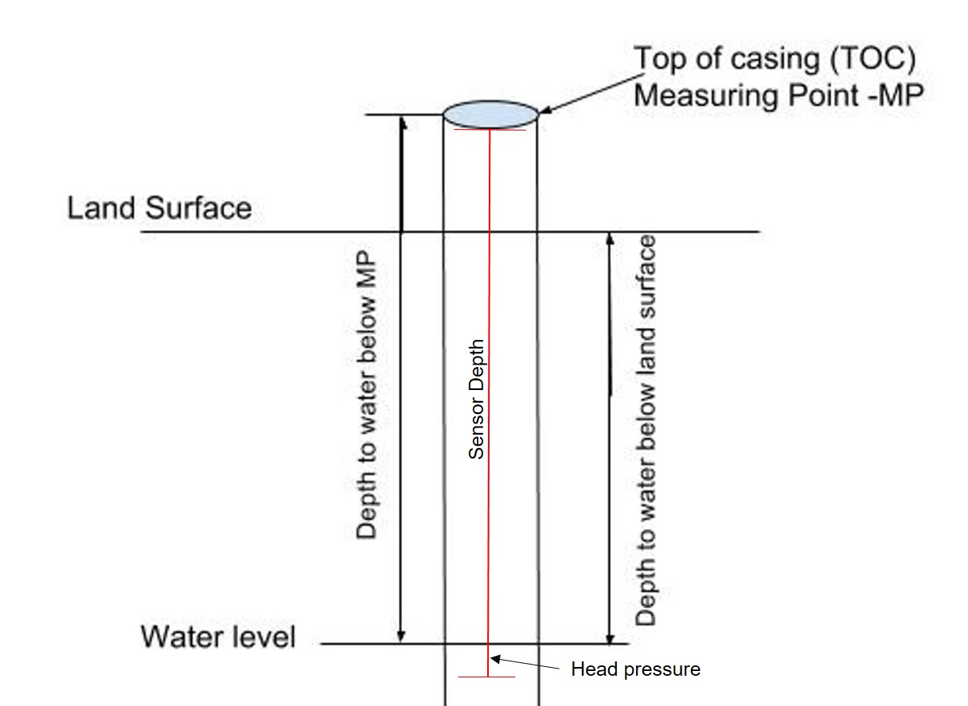  TOC above land surface = 0.60 meters  Sensor location down borehole from MP = 4.70 meters  Well Depth = 4.3 meters  Casing type = pvc  Casing diameter = 3.175 cm  Casing depth = 4.3 meters  Screened depth = 3.8 – 4.3 meters  The water table below land surface obtained by subtracting the head pressure and above ground casing length from the sensor depth.  Quality control:  Data are checked by plotting data in R package and comparing to precipitation and manual water level measurements using a Solinist electric tape. Sensor data are corrected to the manual measurements and prorated between visits. Bad, missing, or erroneous data values are removed or marked with -9999 which could be caused during data downloads and/or malfunctioning sensors.  Data:  2018-10-10: water level drop concurrent due to peristaltic pump & sampling  2018-10-26: water level drop concurrent due to peristaltic pump & sampling
Sites | Cole Farm, Huntingdon County, Barree Township Lat/Long DMS: 40.63641/ -77.94223; (NAD_1983_StatePlane_Pennsylvania_South_FIPS_3702)
Publications | none
Citation | The following acknowledgment should accompany any publication or citation of these data: Logistical support and/or data were provided by the NSF-supported Susquehanna Shale Hills Critical Zone Observatory.
Data Use Notes | The user of Susquehanna Shale Hills CZO data agrees to provide proper acknowledgment with each usage of the data. Citation of the name(s) of the investigator(s) responsible for the data set, in addition to the generic statement above, constitutes proper acknowledgment. Author(s) (including Susquehanna Shale Hills CZO investigators) of published material that makes use of previously unpublished Susquehanna Shale Hills CZO data agree to provide the Susquehanna Shale Hills CZO data manager with four (4) copies (preferably reprints) of that material for binding as soon as it becomes available. The user of Susquehanna Shale Hills CZO data agrees not to resell or redistribute shared data. The user of these data should be aware that, while efforts have been taken to ensure that these data are of the highest quality, there is no guarantee of perfection for the data contained herein and the possibility of errors exists. These data are defined as either public or private, such that a password may be required for access.

