SSHCZO Metadata Worksheet

Data File Name | HV1_9_meter_well.csv
Date Prepared | 09/01/2016
Descriptive Title | Harrys Valley Well 1 (HV1_9m)
Update Frequency | Annually
Abstract | Groundwater level data far Harrys Valley 1 well were measured every 10 minutes using Schlumberger Micro-Diver non-vented pressure transducers. Recorded data began 2015-11-20 through present.
Investigator  Contact Info | Dr. Tess Russo, – Assistant Professor, Department of Geosciences, 310 Deike Building, Pennsylvania State University, University Park, PA 16802, russo@psu.edu, (814)865-7389  Beth Hoagland, neh137@psu.edu, Graduate Student, 502-432-0755
Data Value Descriptions | - COL1: label = TmStamp_UTC; TimeZone = UTC  - COL2: label = water_temp_C; Units = degC, water temperature  - COL3: label = WL_BLG_m; Units = meters
Keywords | Hydrology, groundwater level, groundwater temperature
Methods | Groundwater level measurements were recorded at ten minute intervals using Schlumberger Micro-Diver non-vented pressure transducers. Data were processed using barometric values from a HOBO data logger located at the Garner Run Outlet (40.692454 - 77.927731) and another micro-diver near the well starting. Micro-Diver software is used to download these sensors and have the capability to enter the sensor depth within the software. Manual field measurements are made using a Solinist electric tape to measure water level below ground. These manual measurements are used to apply a prorated correction between visits to create the final water level below ground (WL_BLG_m).  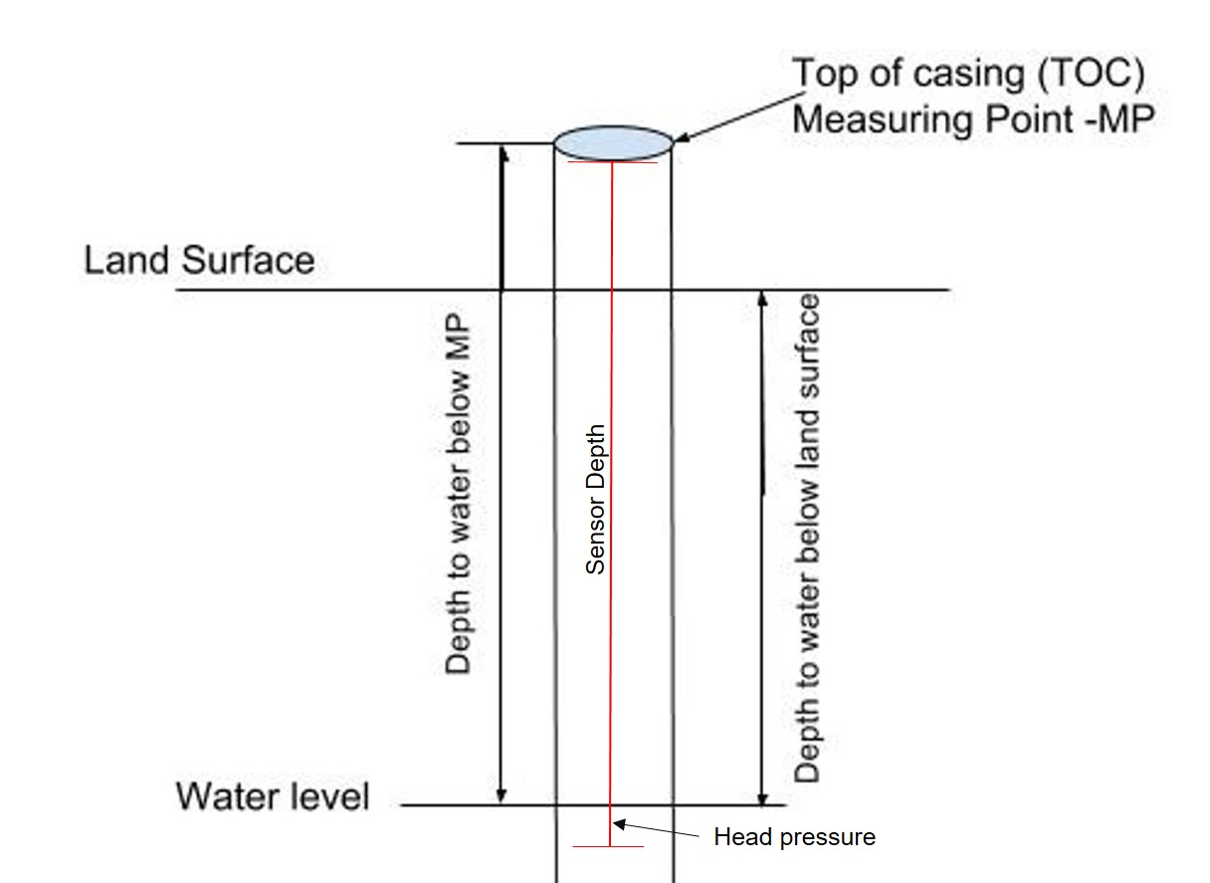  TOC above land surface = 0.48 meters  Sensor location down borehole from TOC = 2.38 meters (2015-11-20 to 2018-01-11)  Sensor location down borehole from TOC = 2.66 meters (2018-01-11 to present)  Sensor location below land surface = 1.90 meters (2015-11-20 to 2018-01-11)  = 2.18 meters (2018-01-11 to present)  -9999 values indicate missing erroneous data during downloads or sensor malfunctions.  Data gaps:  2016-08-15 to 2017-01-03; sensor out of water
Sites | Garner Run (Rothrock State Forest) 40.69775 -77.91889, elevation 529.438m
Citation | The following acknowledgment should accompany any publication or citation of these data: Logistical support and/or data were provided by the NSF-supported Shale Hills Susquehanna Critical Zone Observatory.
Publications | Unpublished, please embargo public access to this dataset.
Data Use Notes | The user of Shale Hills Susquehanna CZO data agrees to provide proper acknowledgment with each usage of the data. Citation of the name(s) of the investigator(s) responsible for the data set, in addition to the generic statement above, constitutes proper acknowledgment. Author(s) (including Shale Hills Susquehanna CZO investigators) of published material that makes use of previously unpublished Shale Hills Susquehanna CZO data agree to provide the Shale Hills Susquehanna CZO data manager with four (4) copies (preferably reprints) of that material for binding as soon as it becomes available. The user of Shale Hills Susquehanna CZO data agrees not to resell or redistribute shared data. The user of these data should be aware that, while efforts have been taken to ensure that these data are of the highest quality, there is no guarantee of perfection for the data contained herein and the possibility of errors exists. These data are defined as either public or private, such that a password may be required for access.

