SSHCZO Metadata Worksheet

Data File Name | SH_DC0_Well_waterlevel.csv
Date Prepared | 2017-04-13; updated 2017-12-05
Descriptive Title | DC_0
Update Frequency | Quarterly
Abstract | Groundwater level data and water temperature for SH_DC0 well are measured every 30 minutes using an In-Situ Inc Level Troll 500 vented pressure transducer. Recorded data began 2013-04-28 through present.
Investigator  Contact Info | Dr. Susan Brantley, Professor of Geosciences, The Pennsylvania State University, 2217 Earth and Environmental Systems Institute, University Park, PA, 16802, 814.865.1619, sxb7@psu.edu.
Data Value Descriptions | - COL1: label = TmStamp_UTC, TimeZone = UTC  - COL2: label = Water_temp_C, Units = degC, water temperature  - COL3: label = WL_BLG_m, Units = meters, water level below ground; corrected based on manual field measurements
Keywords | Groundwater Depth, Groundwater Temperatures, Hydrology
Methods | - Groundwater level measurements are recorded every 30 minutes on an In-Siu Level Troll 500 vented pressure transducer. Data are downloaded using Win-Situ 5 software periodically. Manual field measurements are made using a Solinist electric tape to measure water level below ground. These manual measurements are used to apply a prorated correction between visits.  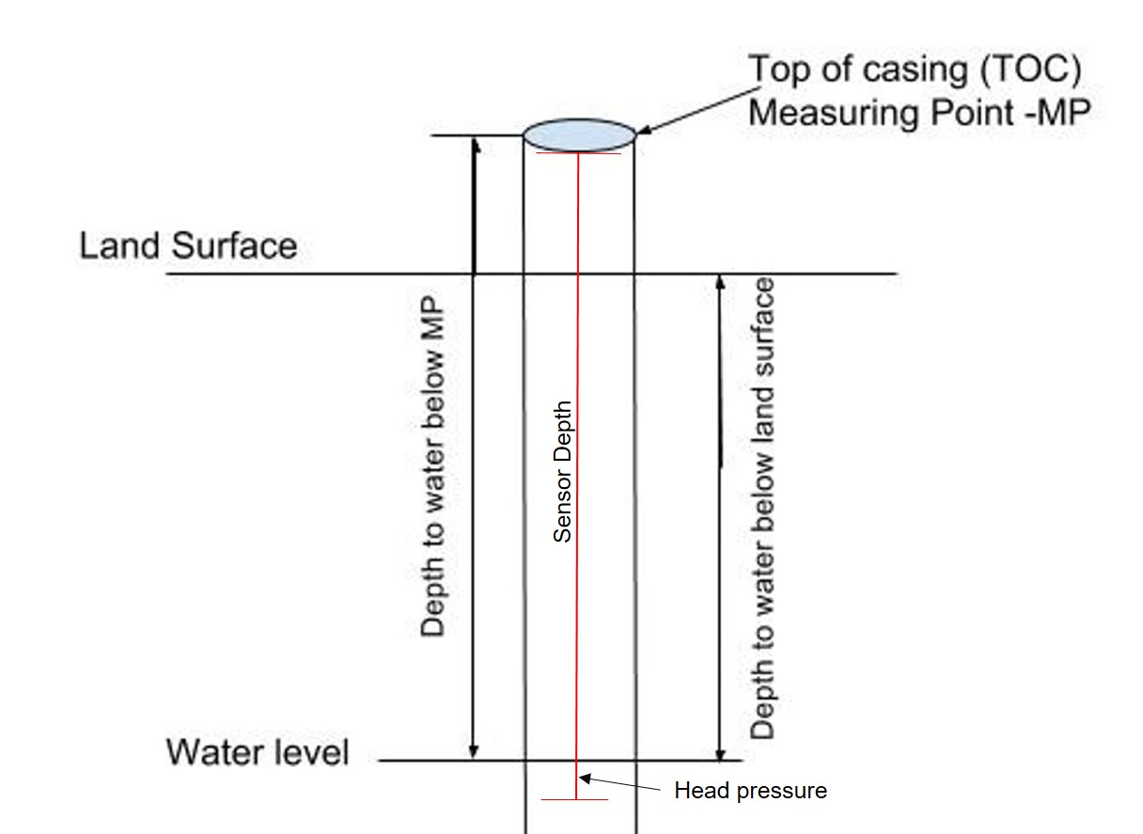  TOC above land surface = 1.23 meters  Sensor location down borehole from TOC = 31.48 meters  Sensor location from ground level = 30.25 meters  The water table below land surface obtained by subtracting the head pressure and above ground casing length from the sensor depth.
Sites | Shale Hills South Ridge Top northing/easting: 147969.01404/ 586976.1606; DMS: 40.66585, -77.90406 (NAD_1983_StatePlane_Pennsylvania_South_FIPS_3702); Elevation = 303.21 meters
Publications | none
Citation | The following acknowledgment should accompany any publication or citation of these data: Logistical support and/or data were provided by the NSF-supported Susquehanna Shale Hills Critical Zone Observatory.
Data Use Notes | The user of Susquehanna Shale Hills CZO data agrees to provide proper acknowledgment with each usage of the data. Citation of the name(s) of the investigator(s) responsible for the data set, in addition to the generic statement above, constitutes proper acknowledgment. Author(s) (including Susquehanna Shale Hills CZO investigators) of published material that makes use of previously unpublished Susquehanna Shale Hills CZO data agree to provide the Susquehanna Shale Hills CZO data manager with four (4) copies (preferably reprints) of that material for binding as soon as it becomes available. The user of Susquehanna Shale Hills CZO data agrees not to resell or redistribute shared data. The user of these data should be aware that, while efforts have been taken to ensure that these data are of the highest quality, there is no guarantee of perfection for the data contained herein and the possibility of errors exists. These data are defined as either public or private, such that a password may be required for access.

