SSHCZO Metadata Worksheet

Data File Name | SH_CZMW7.csv
Date Prepared | 2017-12-05
Descriptive Title | CZMW 7
Update Frequency | Quarterly
Abstract | CZMW 7 was drilled in 2012 using a rotary air. The well is cased to 8 meters with 5 cm diameter pvc and slotted for the bottom 1 meter.  Groundwater level data and water temperature for CZMW 7 are measured every 15 minutes 2017-02-08 to present using a HOBO U20-001-01 non-vented pressure transducer.
Investigator  Contact Info | Dr. Susan Brantley, Professor of Geosciences, The Pennsylvania State University, 2217 Earth and Environmental Systems Institute, University Park, PA, 16802, 814.865.1619, sxb7@psu.edu.
Data Value Descriptions | - COL1: label = TmStamp_UTC; Units = Time Zone = UTC  - COL2: label = WaterTemp_C; Units = degC  - COL3: label = WL_BLG_m; Units = meters; adjusted water level below ground
Keywords | Groundwater Depth, Groundwater Temperatures, Hydrology
Methods | Groundwater level measurements are recorded every 15 minutes on a HOBO U20-001-01 non-vented pressure transducer. Data are manually downloaded monthly using HOBO-Ware Pro software. Sensor depth are calculated in the software by processing with barometric pressure data recorded on a separate HOBO U20-001-01 pressure transducer. Manual field measurements are made using a Solinist electric tape to measure water level below ground. These manual measurements are used to apply a prorated correction between visits to create the final water level below ground (WL_BLG_m).  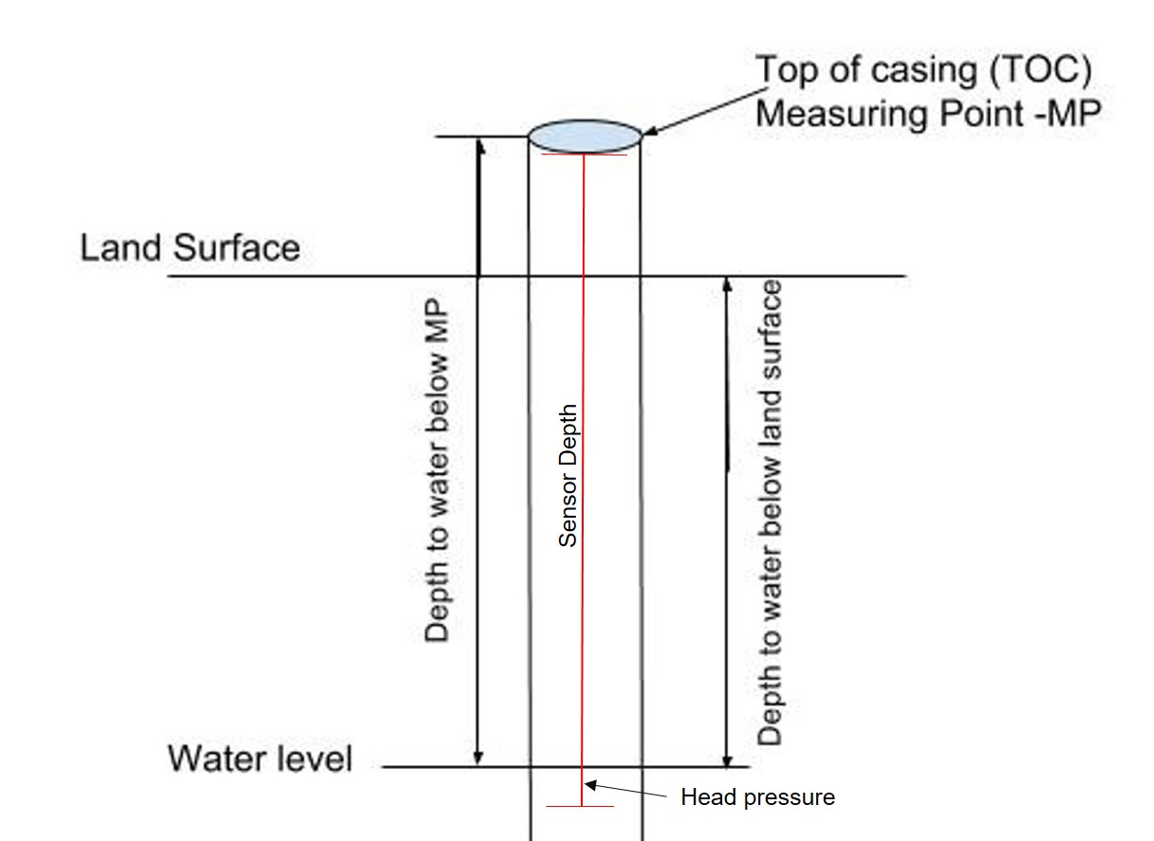  TOC above land surface = 0.68 meters  Sensor location down borehole from TOC = 7.79 meters  Sensor location from ground level = 7.11 meters  Casing type = pvc  Quality Control:  Data were checked by graphing data in R package and comparing to precipitation and manual water level measurements using a Solinist electric tape. Bad, missing, or erroneous data values were removed or marked with -9999 which could be caused during data downloads and/or malfunctioning sensors.  Data gaps:  2017-03-05 to 2017-03-07 : sensor maintenance  2017-07-12 to 2017-08-16 : sensor battery went bad  2019-09-14 to 2019-10-27: sensor failed and replaced; data removed for this period  2021-12-20 to 2022-02-21: sensor failed and replaced; data removed for this period  The water table below land surface is obtained by subtracting the head pressure and above ground casing length from the sensor depth.
Sites | Shale Hills South Ridge Top: northing/easting: 147771.92/ 587065.53.5336; DMS: 40.66408, -77.90297(NAD_1983_StatePlane_Pennsylvania_South_FIPS_3702); Elev: 300.6 meters
Publications | none
Citation | The following acknowledgment should accompany any publication or citation of these data: Logistical support and/or data were provided by the NSF-supported Susquehanna Shale Hills Critical Zone Observatory.
Data Use Notes | The user of Susquehanna Shale Hills CZO data agrees to provide proper acknowledgment with each usage of the data. Citation of the name(s) of the investigator(s) responsible for the data set, in addition to the generic statement above, constitutes proper acknowledgment. Author(s) (including Susquehanna Shale Hills CZO investigators) of published material that makes use of previously unpublished Susquehanna Shale Hills CZO data agree to provide the Susquehanna Shale Hills CZO data manager with four (4) copies (preferably reprints) of that material for binding as soon as it becomes available. The user of Susquehanna Shale Hills CZO data agrees not to resell or redistribute shared data. The user of these data should be aware that, while efforts have been taken to ensure that these data are of the highest quality, there is no guarantee of perfection for the data contained herein and the possibility of errors exists. These data are defined as either public or private, such that a password may be required for access.

