Cole Farm Soil Pit Descriptions
Soil pits excavated June 6, 2017
Soil pits described June 7, 2017
Ashlee Dere, soil pit descriptions
Virginia Marcon and Jennifer Williams, soil samples by depth and horizon

Cole Farm Ridgetop (CFRT)
N° 40 38.234’, W77° 56.580’, elevation 839’ ± 10’
Steeply sloping (32 percent) gully landscape position. Parent material is locally derived colluvium over residuum. Contact with fractured rock angles sharply across the pit: depth to fractured rock is 75 cm on east side of pit and 105 cm deep on west side. Shale is steeply dipping and highly fractured/bladed, with blade size increasing from roughly 4 cm long at 95 cm depth to roughly 10 cm at 150 cm depth. Bottom of the pit is at 160 cm. Water ponded on the downslope end of the pit (roughly 5 cm deep puddle) following a wet week. Water appears to be moving along rock fractures. Roughly 2 cm of Oi horizon above the mineral soil, with dense forest vegetation above.
A | 0 – 9 cm; black (5YR 2.5/1) silt loam; strong granular structure; very friable, nonsticky, nonplastic; many fine and medium roots, few coarse roots; 10 percent shale fragments; clear, smooth boundary.
AB | 9 – 28 cm; dark reddish brown (5YR 3/3) silty clay loam; strong granular structure; very friable, slightly sticky, slightly plastic; many fine and medium roots, common coarse roots; 15 percent shale fragments; clear, smooth boundary.
Bt1 | 28 – 40 cm; reddish brown (5YR 4/4); channery silty clay; moderate subangular blocky structure; friable, sticky, plastic; many fine roots; many faint clay films; 20 percent shale fragments; clear, smooth boundary.
Bt2 | 40 – 69 cm; reddish brown (5YR 4/4) channery silty clay; moderate subangular blocky structure; friable, sticky, plastic; common fine roots; abundant clay films; 25 percent shale fragments; clear, smooth boundary.
Bt3 | 69 – 95 cm; reddish brown (5YR 4/4) channery silty clay; weak subangular blocky structure; very friable, sticky, plastic; common fine roots; abundant clay films; 30 percent shale fragments; abrupt, smooth boundary.
2Cr | 95 – 160+ cm; fractured, oriented (strike 50°, dip 45° SE), bladed reddish brown shale. Size of shale fragments increases with depth. Abundant clay coatings between shale fragments; common moderately distinct iron and manganese concentrations between shale fragments.

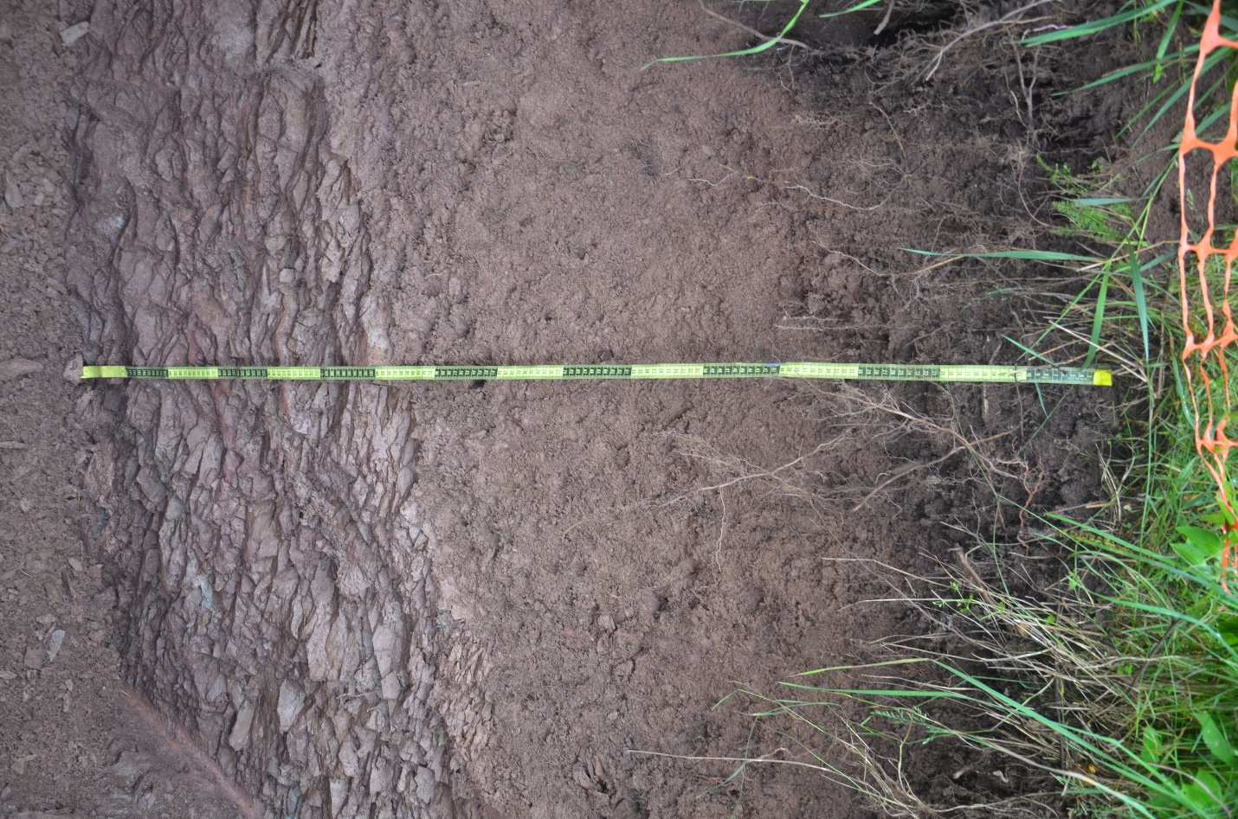
Cole Farm Ridgetop (CFRT) soil profile.

Cole Farm West Midslope (CFWMS)
N° 40 38.163’, W77° 56.547’, elevation 806’ ± 10’
Gently sloping (16 percent) footslope landscape position to the west of incised stream. Water ponded at base of pit (180 – 205 cm). Parent material is locally derived colluvium. Grass vegetation with some forbes, but large roots decomposing as deep as 100 – 110 cm. Cropped field 10 meters upslope.
Ap | 0 – 10 cm; brown (10YR 4/3) silt loam; weak subangular blocky structure parting to moderate granular structure; friable, nonsticky, nonplastic; many fine and common medium roots; clear, smooth boundary.
BA | 10 – 19 cm; dark yellowish brown (10YR 4/4) silty clay loam; moderate subangular blocky structure parting to weak granular structure; friable, slightly sticky, slightly plastic; common fine and medium roots; clear, smooth boundary.
Bt1 | 19 – 40 cm; brown (7.5YR 4/4) silty clay; moderate subangular blocky structure; firm, sticky, plastic; few fine and few coarse roots; few faint clay films; clear, smooth boundary.
Bt2 | 40 – 64 cm; strong brown (7.5YR 4/6) silty clay; moderate subangular blocky structure; firm, sticky, plastic; few fine roots; common faint clay films; common faint iron concentrations and manganese nodules; many worm burrow casts; gradual, smooth boundary.
Bt3 | 64 – 108 cm; dark yellowish brown (10YR 4/4) silty clay; moderate prismatic structure; firm, sticky, plastic; few fine roots; abundant clay films; many distinct concentrations (10YR 5/8) and many distinct depletions (10YR 6/1); clear, smooth boundary.
Bt4 | 108 – 147 cm; dark yellowish brown (10YR 4/4) silty clay; moderate prismatic structure parting to moderate subangular blocky structure; firm, sticky, plastic; few fine and few coarse roots; abundant clay films; many prominent concentrations (10YR 5/8) and many prominent depletions (10YR 6/1), especially as halos around decomposing coarse roots; gradual, smooth boundary.
BC | 147 – 180 cm; yellowish brown (10YR 5/4) clay; weak prismatic structure parting to weak subangular blocky structure; firm, sticky, plastic; few clay films; many prominent concentrations (10YR 5/8) and many prominent depletions (10YR 6/2); gradual, smooth boundary.
C | 180 – 205+ cm; dark yellowish brown (10YR 4/4) gravely clay; massive; firm, sticky, plastic; horizon waterlogged. Roughly 20 percent gravels, but difficult to sample due to ponded water.
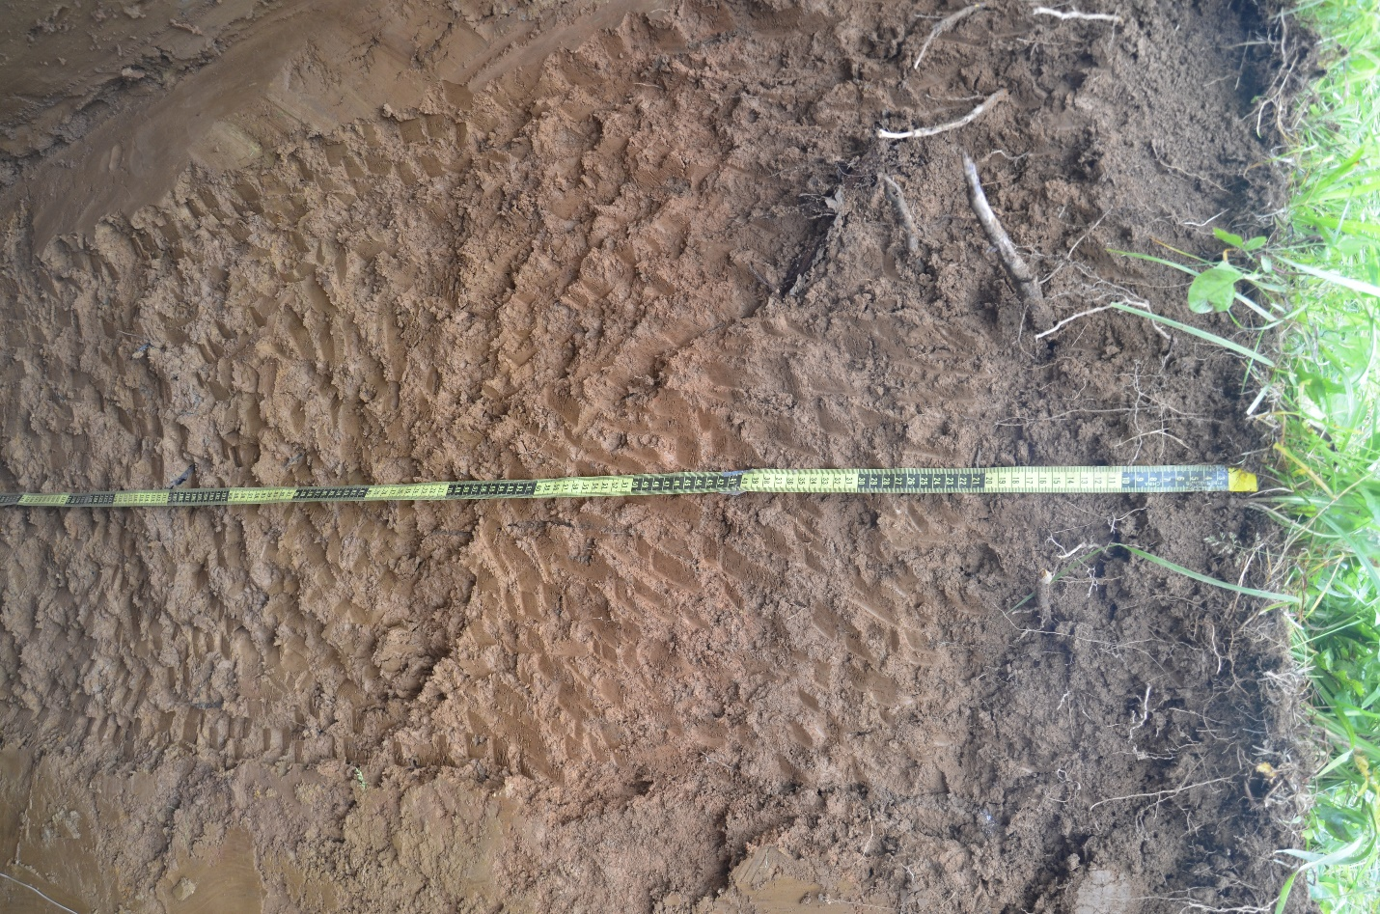
Cole Farm West Midslope (CFWMS) soil profile.

Cole Farm East Midslope (CFEMS)
N° 40 38.185’, W77° 56.529’, elevation 796’ ± 10’
Gently sloping (14 percent) footslope landscape position to the east of incised stream. Water ponded at base of pit (40 cm deep prior to pumping, 160 cm after pumping; pit refilled at a rate of roughly 10 cm per hour). Preferential water flow along large roots in upper 60 cm. Root halos common below 70 cm depth. Parent material is colluvium. Fractured, oriented rock may be below colluvium, but difficult to determine due to water levels. Grass vegetation but very close to edge of forest on the bank of the stream. Cropped field 10 meters upslope.
Ap | 0 – 12 cm; very dark grayish brown (10YR 3/2) silt loam; moderate granular structure; very friable, nonsticky, nonplastic; many fine, common medium and few coarse roots; clear, smooth boundary.
Bt1 | 12 – 31 cm; dark yellowish brown (10YR 4/4) silty clay loam; moderate subangular blocky structure parting to weak granular structure; firm, slightly sticky, slightly plastic; common fine, common medium, and common coarse roots; few faint clay films; faint yellow beige halos surrounding fine roots; gradual, smooth boundary.
Bt2 | 31 – 45 cm; dark yellowish brown (10YR 4/6) silty clay; strong prismatic structure parting to moderate subangular blocky structure; firm, moderately sticky, moderately plastic; common fine, common medium and few coarse roots; common clay films; common faint concentrations and few faint depletions; abundant clay films; clear, smooth boundary.
Btx | 45 – 80 cm; yellowish brown (10YR 5/4) clay loam; moderate prismatic structure parting to moderate subangular blocky structure; very firm, sticky, plastic; few medium roots; common clay films; many distinct iron concentrations (10YR 5/8) and many distinct depletions (10YR 6/2); a few large cobles present; gradual, smooth boundary.
BC | 80 – 112 cm; light yellowish brown (10YR 6/4) clay loam; weak subangular blocky structure; friable, slightly sticky, moderately plastic; few fine roots; abundant clay films; many distinct concentrations (10YR 5/8); 15 percent gravels; gradual, smooth boundary.
C | 112 – 160+ cm; yellowish brown (10YR 5/6) gravelly clay loam; massive; friable, sticky, plastic; few fine roots; common prominent concentrations (10YR 5/8) and few faint depletions (10YR 6/1); 20 percent gravels, some large.
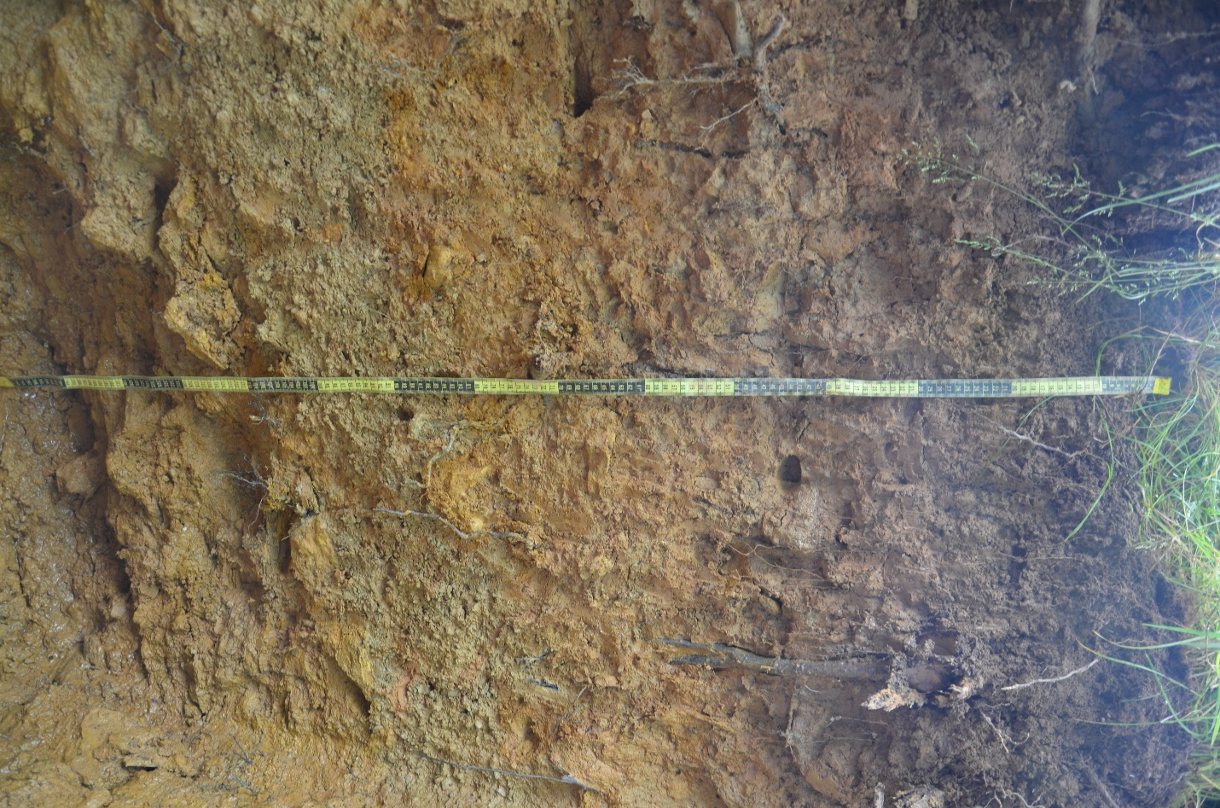
Cole Farm East Midslope (CFEMS) soil profile.

Cole Farm Valley Floor (CFVF)
N° 40 38.021’, W77° 56.458’, elevation 746’ (estimated from GoogleEarth – no direct GPS taken)
Nearly flat slope (1 percent) floodplain landscape position to the north of Shaver Creek. Pit filled with water prior to pumping and refilled rapidly following pumping (roughly 10 cm per 10 minutes). Alluvial parent material. Many vertical worm burrows coated with organic material present from 45 to 70 cm. Oxidized zone above the gleyed horizons that begin at 83 cm depth. Poorly developed structure overall and few faint clay films present. Coarse roots present in upper 25 cm. Grass vegetation, but cultivated at times, and close to riparian forest on the banks of the stream. Large pond approximately 25 m upslope.
Ap | 0 – 11 cm; very dark grayish brown (10YR 3/2) silt loam; strong granular structure; very friable, nonsticky, nonplastic; many fine, common medium and few coarse roots; clear, smooth boundary.
Bw1 | 11 – 36 cm; brown (10YR 4/3) silt loam; weak subangular blocky structure; very friable, nonsticky, nonplastic; few fine, common medium, and few coarse roots; very few faint clay films; few faint concentrations; clear, smooth boundary.
Bw2 | 36 – 60 cm; brown (7.5YR 4/4) silt loam; weak subangular blocky structure; very friable, slightly sticky, slightly plastic; common fine and medium roots; very few faint clay films; few faint concentrations and few faint depletions; gradual, wavy boundary.
BC | 60 – 83 cm; brown (7.5YR 5/4) silt loam; weak subangular blocky structure; friable, slightly sticky, slightly plastic; few fine roots; many distinct iron concentrations (10YR 5/8) and common faint depletions (10YR 5/2); clear, smooth boundary.
Cg1 | 83 – 103 cm; gray (10YR 5/1) loam; massive; friable; common prominent concentrations (10YR 5/8); clear, wavy boundary.
Cg2 | 103 – 120+ cm; gray (Gley 1 5/N) sandy loam; massive; friable; few faint concentrations (10YR 5/8).

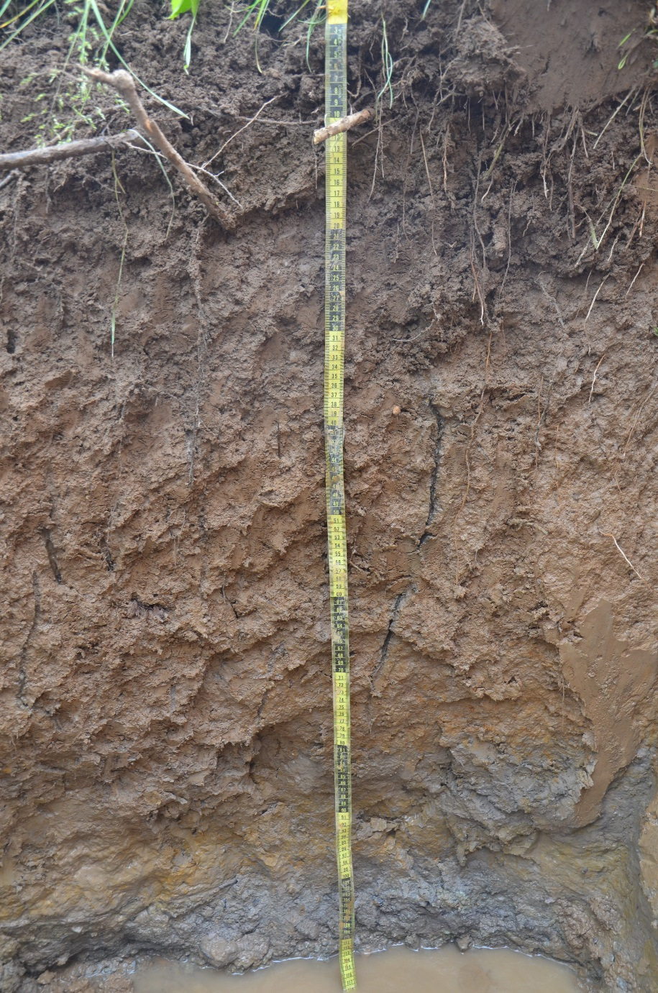
Cole Farm Valley Floor (CFVF) soil profile.

Cole Farm East Ridgetop Core (CFERTcore)
N 40° 38' 18.4776" W 77° 56' 28.0098" Elevation 906’ (estimated using GoogleEarth)
Core collected August 21, 2017 by Virginia Marcon, Wenjing Liu, Jennifer Williams, and Brandon Forsythe. Virginia Marcon has photos and GPS location for the site. Soil augered manually in 10 cm intervals using a 7 cm diameter bucket auger to refusal at 70 cm. Soil core was collected at the highest point of the ridge northeast from the CFRT soil pit, in the woods near the edge of the cultivated field. Air dried core described in the PSU 315 Hosler Soil Prep Lab on October 5, 2017 by Ashlee Dere.
Ap | 0 – 15 cm; dark yellowish brown (10YR 4/4) silty clay loam; weak to moderate granular structure; friable, slightly sticky, slightly plastic.
Bt1 | 15 – 40 cm; yellowish brown (10YR 5/4) silty clay; moderate subangular blocky structure; firm, sticky, plastic; common clay films.
Bt2 | 40 – 55 cm; yellowish brown (10YR 5/4) clay; weak to moderate subangular blocky structure; firm, sticky, plastic; common clay films; 10 percent shale fragments.
BC | 55 – 70+ cm; light yellowish brown (10YR 6/4) channery silty clay; weak subangular blocky structure; friable, sticky, plastic; few faint clay films; 20 percent shale fragments.

